Setting up “Account Codes” in your Print Driver

- When setting up “Account Codes” in your print driver, select “File” then select the “Print” option. (Seen in screenshot below).
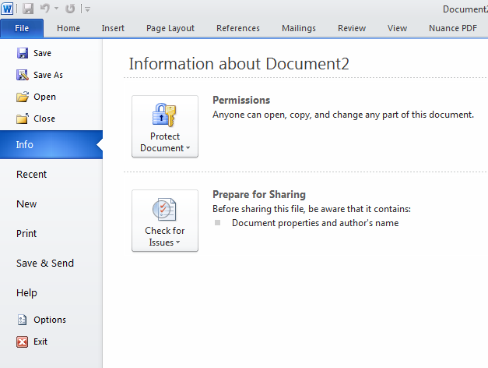

- New page opens. Click the “Printer Properties” link (Seen in screenshot below).
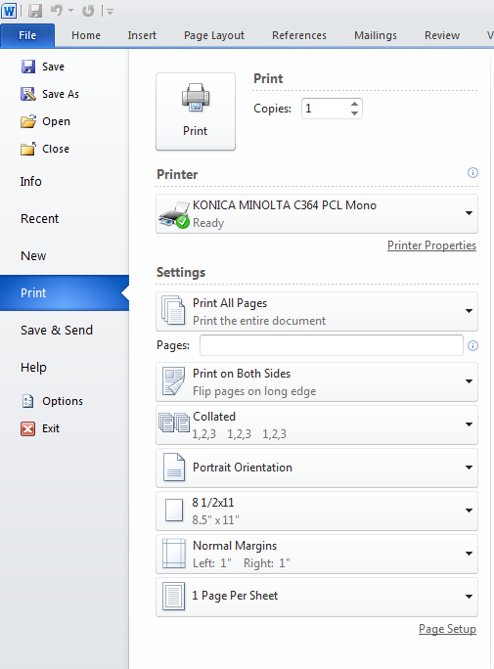

- Choose the “Basic” tab (Seen in screenshot below).
- Click “Authentication/Account Track” (Seen in screenshot below).
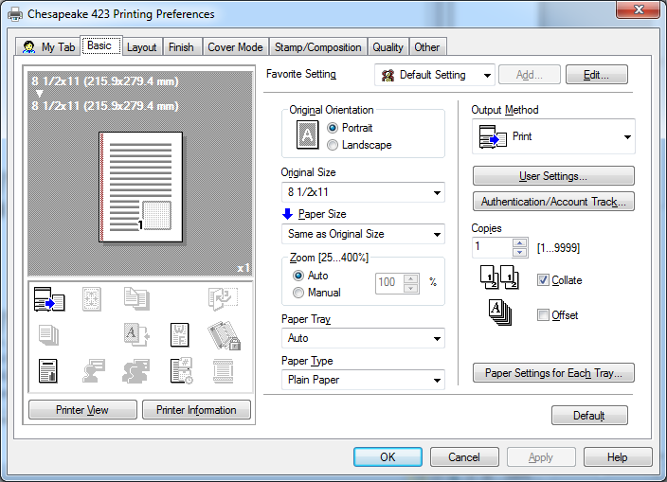

- Enter the Account Code for the User (Seen in screenshot below).
- Once you enter the code, Click “Verify” to check communication and then Click “OK” (Seen in screenshot below).
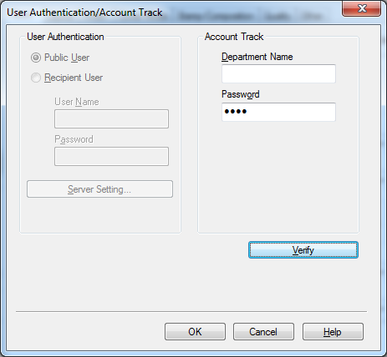

- Click on “Apply” to lock the code into the print driver. Now this user will be able to print and be tracked for their usage (Seen in screenshot below).

- Back in the Print Driver, choose the “Basic” tab (Seen in screenshot below).

- Change “Output Method” to “Save in User Box”. Then in “User Settings” Page enter the Number of the User Box found on the User Box screen for the corresponding name. Then Click OK. When this Pop-Up closes Click “Apply” to save this setting (Seen in screenshot above).

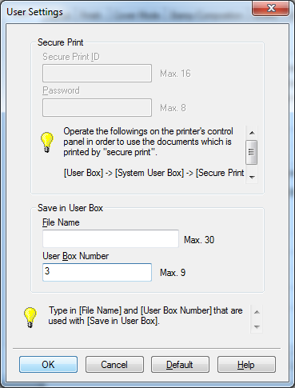
- The driver is now ready to print into a User Box as the Default setting.

How to set up the “Popup” dialog as the default setting on an end users driver that needs to use Multiple Account Codes
- Choose the proper Print Driver from your “Printers and Faxes (XP)” or ”Devices and Printers”(Win7), Right-Click and choose “Properties(XP)” or “Printer Properties(Win7)”.
- Go to the “Settings” tab (top right hand tab)
- Click on the “Popup Authentication Dialog when Printing” and then Click “Apply”.
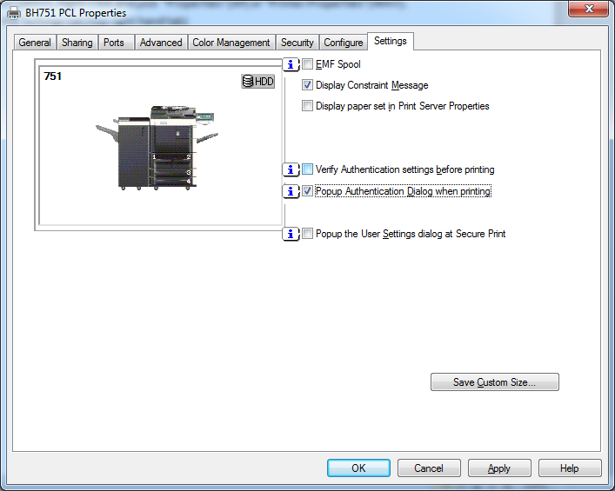
- You are now going to get the Pop-UP Authentication window each time you press “Print”.
Note: If the Pop-up Authentication option is chosen you will need to enter the correct Account Code to print to the correct account each time you use the driver.

