Printing to “Secure Print”

- When printing a document with Secure Print select “File” then select the “Print” option. (Seen in screenshot below).
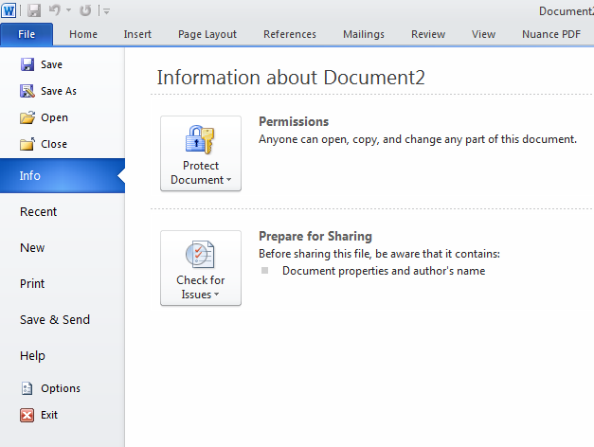

- New page opens. Click the “Printer Properties” link. (Seen in screenshot below).
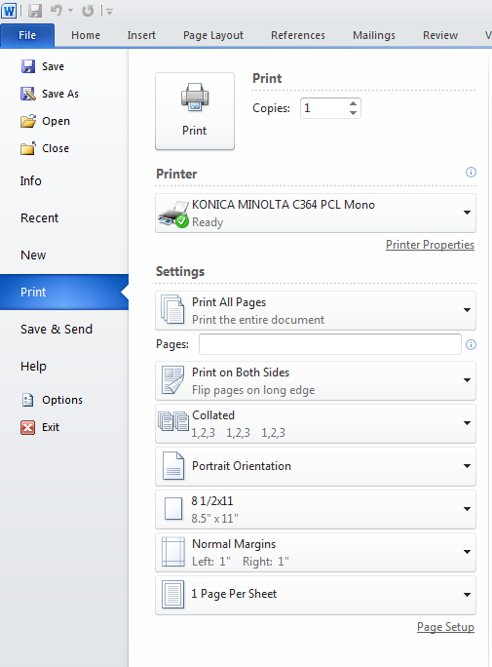

NOTE: Your Screen may look slightly different as this is being shown on a Windows 7 or Windows 8 Computer

- Go to the “Basic” Tab and under the Output Method dropdown Choose “Secure Print” (Seen in screenshot below).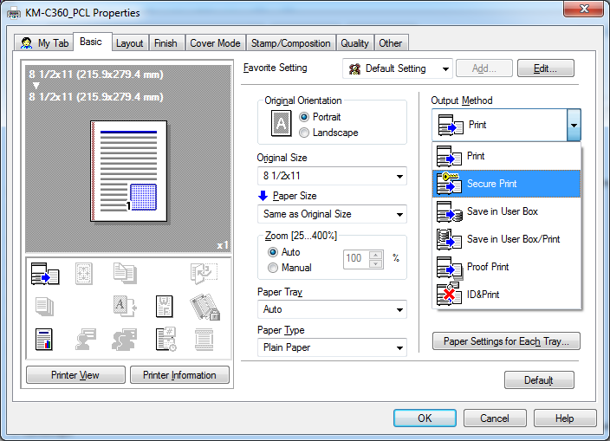

- A new window will open. In the new “User Settings” Box, fill in the ” Secure Print ID” and “Password” fields with the ID you have selected as your Secure Print ID and then enter your Password. The password can be whatever you would like it to be and it also could be the same or different with each print you do. (Seen in screenshot below).
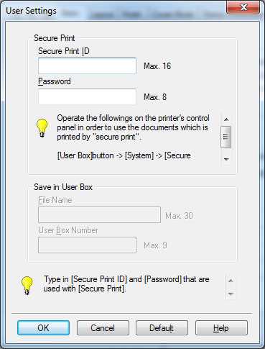
- Click “OK” to move to the next screen.

- Verify that all your printer settings are correct and click “OK”. At this point you should be back to the original “Print” Screen, Click “OK” and your job will be sent to the Printer.

Retrieving Print Jobs from the KM Device
- At the Operator panel on KM Device, Choose “User Box”
- Choose ‘System User Box’ tab at the top of the screen, then select “Secure Document User Box”
  - In the lower right corner select Use/File
- On the new screen Type in your Secure Print ID and Password. NOTE: These are both case sensitive
- Select your Job(s)
  - Press the Print button on Upper Right of Panel
  - Set any print settings that you want to change
  - Click on Start on the Screen or push the Blue Start Button on Operator Panel.

