Fall 2015-Spring 2016 Study Abroad Information
Deadline for receipt:
Fall: August 1
Spring: November 1

The financial aid programs available for Study Abroad include Federal Pell Grant, Federal Direct Loans, Federal Parent Loans (PLUS), Alternative Loans, and various Scholarship programs. Students must submit the following items for files to be complete:

All students must submit the following items for files to be complete:
- UMW "Request for Study Abroad Financial Aid" Form and supporting documentation of program costs from the program literature.
- Consortium Agreement from the study abroad institution must be signed and returned. The Office of Financial Aid initiates this with the host institution. It will show “satisfied” in your Eagle Net portal upon certification by the host institution.

Enrollment:
- Students who participate in study abroad programs are required to maintain full-time enrollment (12 credits or more) to receive their maximum financial aid award.
- Should a student drop below 12 credits, they should notify the UMW Center for International Education and the UMW Office of Financial Aid. Note: Dropping below full-time enrollment may require the return of financial aid to federal programs.

Study Abroad Scholarships:
- Students may inquire about these programs through the UMW Center for International Education (CIE).

Study Abroad Loan Options
- Federal Loan programs require enrollment in approved UMW study abroad program for a minimum 10-week period with a minimum of six (6) credit hours. OR, a student may enroll for a minimum of six (6) credit hours and attend both UMW summer sessions (one may be a study abroad program).
- Alternative Loan Programs have differing requirements regarding enrollment dates. Please contact the appropriate lender for this information.

Receipt of Funds:
- The University of Mary Washington will disburse aid to students based on the University’s regular disbursement schedule. If a Consortium Agreement is approved by the host institution, that institution agrees to wait until an approved date for payment in the amount that the student is receiving in financial aid.
- It is the student’s responsibility to ensure the study abroad institution receives the funds. Study abroad programs will not receive student financial aid funds directly from the University of Mary Washington.
- The Office of Student Accounts encourages students to enroll in direct deposit to receive the funds.
- If the student chooses not to enroll, the funds will automatically be sent in the on campus UMW mailbox.
- Financial aid funds will not be available for required program deposit fees or upfront costs. The payment of financial aid funds for the summer semester will occur in late June, regardless of the program dates, assuming that all requirements have been completed and approved by the stated deadline.

Students are encouraged to meet with a financial aid Director to discuss this process. To set up an appointment, or speak to a financial aid representative, please call (540)654-2468, send an email to finaid@umw.edu, or visit the Financial Aid office, which is located in Lee Hall.

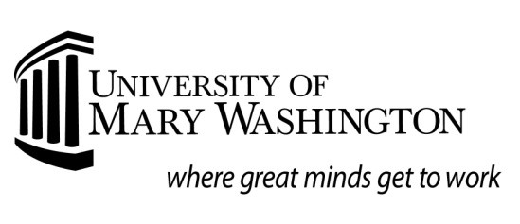Request for Study Abroad Financial Aid
Deadlines for receipt: Fall: August 1
Spring: November 1
Summer: April 15

Name: _

Banner ID:
Academic Term: Program Dates: to

Study Abroad Program Information (do not use UMW Center for International Education)
Program Name:
Contact Name:
Address:
Phone: | Fax: | Email:
CIE Use ONLY. Has student completed _Course Approval; _received Acceptance into above program

UMW credits approved: _ Signature of CIE Staff Member: _

Study Abroad Program Costs (supply supporting documentation from program literature)
Tuition
Housing
Meals
Books and Supplies
Transportation
Program Fees
UMW Study
Abroad Fee
Other (specify)
Please process the appropriate financial aid for the above study abroad program. I understand that not
all aid previously awarded is eligible to be used for study abroad and that it is my responsibility to submit all required documents to the Office of Financial Aid. Additionally, unless I have enrolled in Direct Deposit, I understand that funds will be sent to my mailing address. I understand that it is my responsibility to make full payment to above listed study abroad program.

Student signature Date

