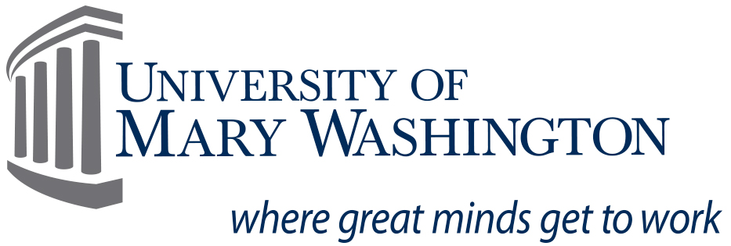 2015-2016 Federal Direct PLUS Request Form

The Federal Direct PLUS Program is intended for 1) an eligible parent to borrow federal funds on behalf of a son or daughter who is a dependent undergraduate student or 2) a graduate/professional student. Awarded funds are intended to assist with payment of the student’s educational expenses and are borrowed from the U.S. Department of Education.
The person who is applying to be a Federal Direct PLUS Loan borrower must complete this form. Only Natural, Adoptive or Stepparents OR graduate/professional students are eligible to borrow through this program.
Students must have a valid Free Application for Federal Student Aid (FAFSA) and a completed federal PLUS loan application before the school will process Direct Parent Plus Loans.
A parent may borrow up to the total cost of attendance minus all the financial aid and resources received by the student. If the loan is for one semester only, the loan amount is based on the cost of attendance for that semester minus the financial aid and resources for that semester.

When requesting a specific amount, please keep in mind that the Department of Education will deduct a 4.272% origination fee from the amount that you request. For example, if you request $1000 then the amount that will be applied to the student’s account will be $957 ($1000 - $43 fee).

SECTION A – To be completed by the Student or Graduate/professional Student:

Last Name__________________________ First Name _________________________ Banner ID Number_________________
SECTION B – To be completed by the parent borrower OR graduate student borrower as it appears on the PLUS application

Name: _____________________________________________________ Last four digits of SSN: _______________
Address: ______________________________________________________________________________________
Work Phone: ______________________________________ Home Phone: _____________________________
Email: ____________________________________________________________
Are you a U.S. citizen? Yes No
If No, An eligible non-citizen may borrow a PLUS but must be a permanent resident or other individual who can provide documentation from the U.S. Immigration and Naturalization Service that he or she is in the United States for a purpose that is not temporary, with the intention of becoming a citizen or permanent resident.

- Indicate the GROSS Loan Amount that you wish to borrow: $________________ (Whole Dollar amount)
(If you wish to borrow up to your student’s entire Cost of Attendance then you may write “Maximum”)
Please indicate for what period this loan is for: fall 2015 spring 2016 fall and spring 2015-2016

- This loan is an addition to my original request. The additional amount needed is: $ .

Please indicate for what period this loan is for: fall 2015 spring 2016 fall and spring 2015-2016

- Summer term is must be applied for separately as it is not part of the regular 2015-2016 academic year.

The loan amount that you wish to borrow for the summer term of the 2015-2016 academic year: $_____________

SECTION C – Disclosure and Certification
I consent to the U.S. Department of Education and its agents to review my credit report and use the information from that report in determining whether to award a Federal Direct PLUS loan to me. I understand that I will be notified in writing of the results of the credit check and that I must have a Master Promissory Note (MPN) on file before funds can be disbursed. I also attest that I have read and agree to the Privacy Act Disclosure Notice located on our website at www.umw.edu/financialaid.

Parent’s Signature Date

