Search for Help in the PeerNet
The PeerNet feature in the Knowledge Center is a great way to get help from your peers. Think of the PeerNet as a collection of online business cards containing contact information and areas of expertise. You can search for a specific area of expertise and view a list of fellow employees who have listed that expertise in their user profile.
*For instructions on making your area(s) of expertise available for search in the PeerNet, please refer to the Enter Qualifications in the Knowledge Center instructions.
To search for a peer with specific expertise:
- Open the Knowledge Center Login Page (https://covkc.virginia.gov/UMW).
- Enter your Login ID and Password.
- Click the Submit button. The Knowledge Center Home Page opens.
- From the Student Center folder, select the PeerNet option. The PeerNet window opens.
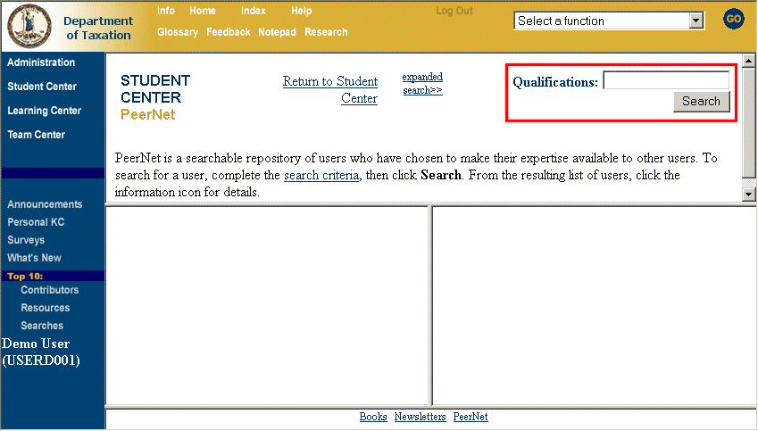
- Enter the area of expertise for which you want to locate someone in the Qualifications field.
- Click the Search button. All users who have listed that qualification in their user profile displays in the lower-left frame of the PeerNet window.
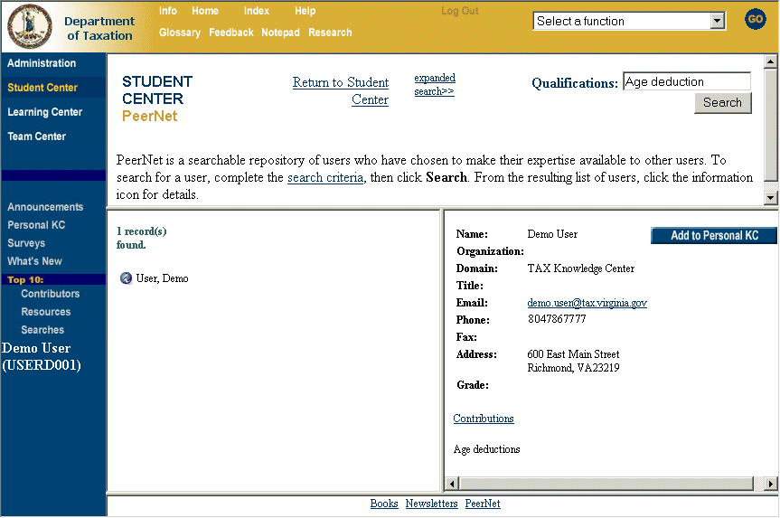
- Click the blue icon to the left of the user’s name. The user’s contact information is displayed in the right frame of the PeerNet window.
Note: To add this user to your list of peers in your Personal KC, click the Add to Personal KC button.

