July 2015
Service Award Recipients

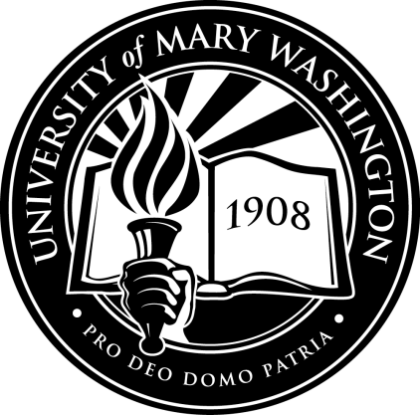
20 Years:
Regina Spencer
Linda Thornton
15 Years:
Suzanne Houff
Beate Jensen
Charles Tate
10 Years:
David Hatcher
Betsy Labar
Janet Sokol
5 Years:
Peter Catlin
Mary Gendernalik-Cooper
Marion Sanford

