December 2017
Service Award Recipients

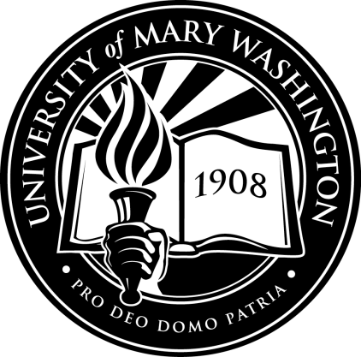
5 Years:
Laura Moyer

10 Years:
Linda Westerman

