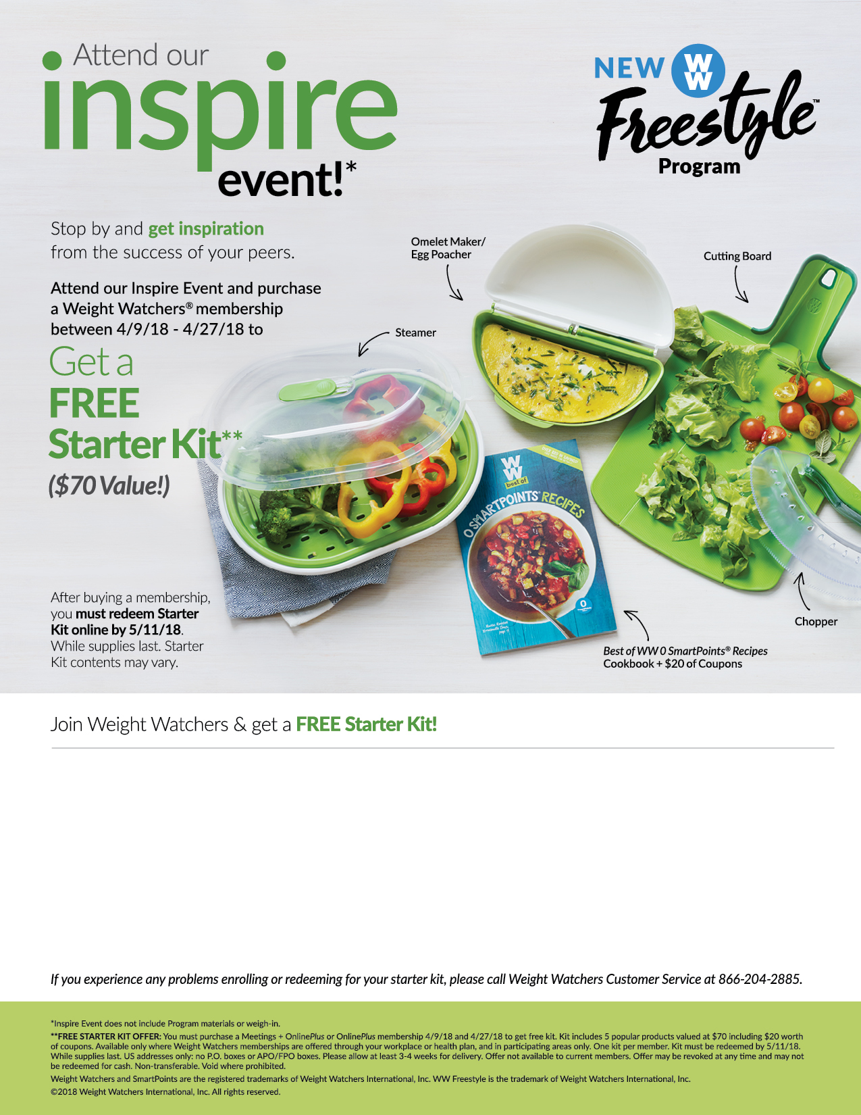

Enroll in Weight Watchers by going to https://wellness.weightwatchers.com, UMW Employer ID: 63569, Employer Passcode:ww63569.  Follow the instructions to enroll.

Attend the Weight Watchers **Inspire Event** at your worksite:

Date & Time: **Every Thursday at 12:15 pm -12:45 pm**

Room: **HCC #111**

**Step 2**

**Step 1**

Once enrolled, redeem for your Starter Kit by going to **weightwatchers.com/atworkstarterkit** and enter your member registration number and shipping address. **Complete this step by 5/11/18.**

**Step 3**

Registration will be available (most major credit cards and personal checks are accepted).