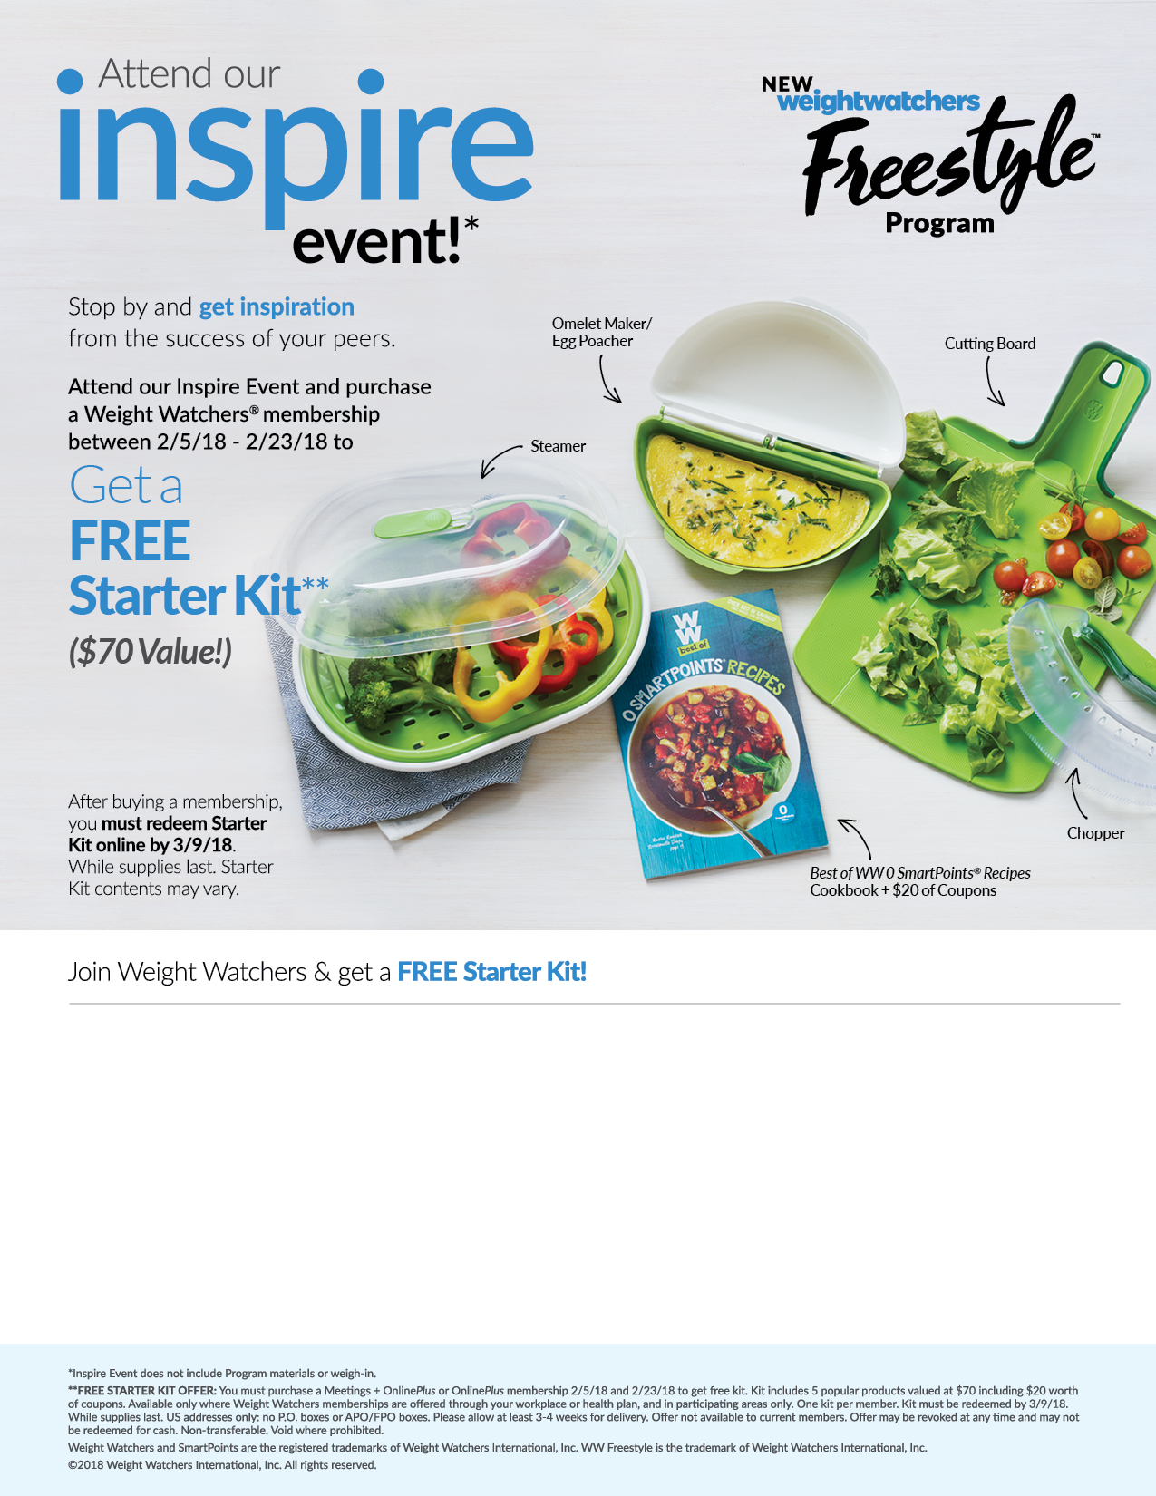

*If you experience any problems enrolling or redeeming for your starter kit, please call Weight Watchers Customer Service at 866-204-2885.*

**Step 2**

**Step 1**

Attend the Weight Watchers **Inspire Event** at your worksite:

Date & Time: **Thursdays 12:15pm**

Room: **HCC room 111**

Once enrolled, redeem for your Starter Kit by going to **weightwatchers.com/atworkgift** and enter your member registration number and shipping address. **Complete this step by 3/9/18.**

Enroll in Weight Watchers by going to https://wellness.weightwatchers.com, and input the UMW Employer ID: **63569**, Employer Passcode: **WW63569**.  Follow the instructions to enroll.

**Step 3**

Registration will be available (most major credit cards and personal checks are accepted).