November 2015
Service Award Recipients

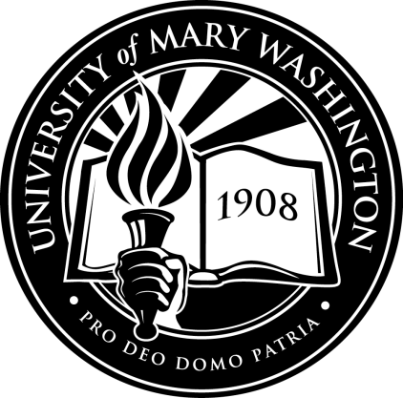
25 Years:
David Berreth
15 Years:
Kathryn Grant
De’Onne Scott
10 Years:
Julia Olsen
Martha Sisk
5 Years:
Takera Green
Lisa Marvashti

