April 2016
Service Award Recipients

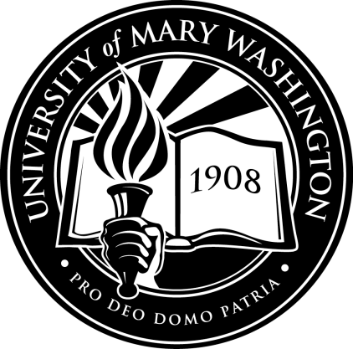
20 Years:
Jeanette Holmes
Kevin Wilkins
15 Years:
Lynda Worthy
10 Years:
James Ashmore
Rosa Mata
Judy Norton
Pamela Verbeck
5Years:
Corey Patton
Paula Zero

