It doesn’t matter how your day has gone.
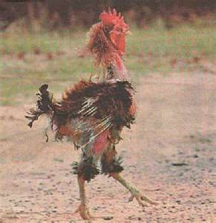
Always go home with your head held high.
Plucked, pounded, mistreated, but still with dignity.
Attitude is everything.

