NON-EXCLUSIVE COLLEGIATE LICENSING AGREEMENT

NON-EXCLUSIVE LICENSE

Whereas, University of Mary Washington (hereafter called the "University") is the owner of all rights, titles, and interests in and to certain designations comprising designs, trademarks, and service marks, logo types, seals, and certain logo graphics and/or symbols that have come to be associated with the University (hereinafter called "Licensed Marks"; and

WHEREAS__________________________________________________________
(hereinafter called "Licensee"), desires to make use of one of more of said Licensed Marks.

WHEREAS, the University has exercised its rights of ownership with respect to said Licensed marks in the United States.

THEREFORE, in consideration of the premises and mutual promises and covenants herein contained, the parties hereto agree as follows:

I. DEFINITIONS

1. "Licensed Marks" means the designs, trademarks, service marks, logo graphics, and/or symbols that are associated with the University and are depicted in Appendix A, which is hereby incorporated by reference.
2. "Licensed Articles" means the articles of merchandise or products using one or more Licensed Marks, which are described in Appendix B, which is hereby incorporated by reference.
3. "Net sales" means the gross wholesale invoice amounts billed customers less quantity discounts actually allowed and taken by the customer and any credits for returns actually made as supported by credit memos issued to customers. No costs incurred in the manufacturing, selling, advertising, or distributing the goods, or an indirect expenses shall be deducted, nor shall any deduction be made for uncollectible accounts, cash discounts, or similar allowances.
4. "Premium" means any article given free or sold at less than the usual selling price for the purpose of increasing the sale of, or publicizing any other product or service, or for any other giveaway or promotional purposes.

II. GRANT OF LICENSE

1. Subject to the terms and conditions of this Agreement, University hereby grants to the Licensee a non-exclusive, non-transferable license to use the Licensed Marks on and in conjunction with marketing, promotion, and sale of the Licensed Articles in the United States and Canada. Licensee’s use or reference to the Licensed Marks shall inure to the benefit of University and all rights with respect to the Licensed Marks not specifically granted in this Agreement shall be and are hereby reserved to the University.
2. Licensee agrees to use its reasonable best efforts to mark all uses of the Licensed Marks with the symbol TM or the symbol ® as designated for each Licensed Mark in Appendix A.
3. Licensee shall have no right to sublicense others to use the Licensed Marks.
4. No License is granted under this Agreement for the use of Licensed Marks in connection with Premium programs. Premium programs using Licensed Marks must have the prior written approval of the University Licensing Director.

III. ROYALTY PAYMENTS AND REPORTS

1. Rate. Licensee agrees to pay the University a royalty of eight percent (8%) of net sales of all Licensed Articles sold during the term of this agreement and any renewals thereof. Sales to the University Bookstore, and University funded student group purchases are exempt from royalties and other licensing fees.
2. Initial Licensing Fee. Licensee will pay to the University an initial fee of one hundred dollars ($100.00) at the time this Agreement is submitted. Each licensee shall pay an annual fee of fifty dollars ($50.00) to remain licensed. Annual fee is due in January.
3. Reports and Records. Licensee shall provide quarterly reports to the University within thirty (30) days following the last day of the months of March, June, September, and December (calendar quarter) on all items manufactured, distributed, and sold. Licensee agrees to keep full and accurate records to show the basis for calculation or royalties and such records, including sales invoices and Licensee's general accounting records shall be open to inspection by the University's representative at reasonable times, and within normal business hours. The University representative shall report to University only on the accuracy of the reports rendered by Licensee.
4. Royalty Payments. For purposes of determining royalty payments, sale shall be deemed to have been consummated at the time of invoicing or billing for said Licensed Articles or at the time of delivery thereof, whichever is earlier. Payments shall be made quarterly during the month following each calendar quarter to University of Mary Washington and sent to the Licensing Coordinator, UMW Business Services, 1301 College Ave., Fredericksburg, VA 22401.
5. Delinquent Payments. All delinquent amounts not paid may be charged the maximum rate of interest permitted under applicable state law, not to exceed one and one-half percent (1 and 1/2%) per month on any portion thereof during which said amounts remain delinquent.
6. Multiple Royalty Payments. The University recognizes that the licensee may be subject to other license agreements which together with this agreement would subject certain Licensed Article to one or more additional royalty payments. The University may agree to a reduced royalty subject to written approval of the University Licensing Coordinator.

IV. TERM

The initial term of this Agreement shall be the calendar year in which it was signed and the agreement shall be automatically renewed for additional one year terms every January unless terminated by either party giving to the other not less than thirty (30) days written notice prior to the expiration of any one year period. Upon such termination, all rights granted to Licensee herein shall cease, except that Licensee may sell all products on hand in inventory at the time of termination provided that Licensee shall pay to University the royalties and provide reports as required in section III.

V. PRODUCT QUALITY

Licensee agrees to maintain high standards of quality and workmanship on the licensed products sufficient to maintain the goodwill attached to the Licensed Marks which are the subject of this agreement. University reserves the right to inspect and approve the quality and propriety of items carrying the Licensed Marks. All items are subject to approval by the University Licensing Coordinator prior to initial licensing.

VI. LIMITATION OF LIABILITY

University shall not be liable to Licensee, or its officers, director, affiliates, agents, employees, contractors or assigns for any CONSEQUENTIAL, SPECIAL, INCIDENTAL, INDIRECT, OR PUNITIVE DAMAGES as a result of the breach or claimed breach of this Agreement, or any warranty, representation, covenant or obligation contained herein.

VII. INDEMNITY

Licensee agrees to hold the University harmless from any and all liability, of whatever the nature or description, arising out of or relating in any manner to the items produced or sold by the Licensee. Approval by the University of a particular product shall not be deemed as an endorsement by the University of the usefulness or safety of the product bearing the Licensed Marks, nor shall such approval be deemed in any manner a guaranty or warranty of any nature with respect to the items approved. Proof of adequate liability or product insurance will be provided to University upon request.

VIII. EVENT OF DEFAULT

Without prejudice to any other rights, the University shall have the right to terminate this agreement upon written notice to Licensee at any time if Licensee shall fail to make payment due hereunder or to deliver any of the reports herein referred to and if such default shall continue for a period of 10 days after written notice of default is given by the University. The University may terminate this agreement immediately if Licensee fails to comply with any express approval obligation set forth herein.

IX. ENFORCEMENT

If Licensee learns of any activity by a third party which might constitute an infringement of the University’s interest in any of the Licensed Marks or if any third party asserts that Licensee’s use of any of the Licensed Marks constitutes unauthorized use or infringement, Licensee shall so notify the University. The University will endeavor to investigate unauthorized use by others of the Licensed Marks brought to its attention by Licensee. However, nothing in this agreement shall require the University to bring suit or take action for infringement of any of the Licensed Marks.

X. ASSIGNMENT

This agreement and any rights herein granted are personal to the Licensee and the University and shall not be assigned, sublicensed or encumbered, except to a subsidiary of the Licensee, without the written consent of the University which shall not be unreasonably withheld.

XI. NO WAIVER.

The failure of either party to insist upon strict performance of any of the terms or provisions of this Agreement, or the exercise of any option, right or remedy contained herein, shall not be construed as a waiver of any future application of such term, provision, option, right or remedy unless expressly provided in a writing signed by the waiving party.

XII. INTEGRATION

This agreement constitutes the entire agreement between the parties as to the licensed items, and no modifications or revisions hereof shall be of any force or effect unless the same are in writing and executed by both parties hereto. This Agreement may be executed in any number of counterparts, each full set of which shall be deemed an original, with the same effect as if the signatures where upon the same instrument. This agreement shall be governed by and construed in accordance with the laws of the State of Virginia, without resort to the conflicts of laws rules thereof.

_______________________________________________________
Signed University of Mary Washington
Licensing Coordinator

_______________________________________________________

University of Mary Washington
Chief Procurement Officer

_______________________________________________________
Licensee

_______________
Date

Company correspondence address:

Appendix A

University is the owner of all rights, title and interest in and to the following indicia, which includes trademarks, service marks, trade names, designs, logos, seals, and symbols.

Approved colors
Minor variations of Pantone colors will be accepted

Dark Blue Pantone 648 White
Cool Gray Pantone Cool Gray 11

Verbiage
University of Mary Washington UMW
UMW Eagles Eagle Nation

Graphics
UMW Tagline Logo UMW Monogram Logo
Mascot UMW Seal
UMW Athletics Eagle UMW Brand Extension Logos

U.S. Reg. No. 423763:

®

U.S. Reg. No. 4337319:
®

U.S. Reg. No.4337318:
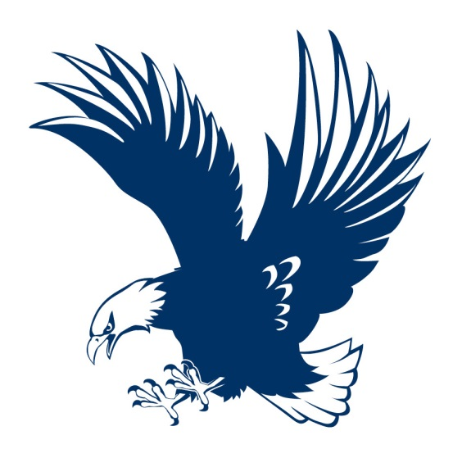®

In addition to the indicia shown, any indicia adopted hereafter and used or approved for use by the University shall be deemed to be additions to the indicia as though shown above and shall be subject to the terms and conditions of the Agreement.

University of Mary Washington
Lauren McDonald
Licensing Coordinator
1301 College Ave.
Fredericksburg, VA 22401
Appendix B
The following merchandise types are approved for UMW branded self-licensing program.
Apparel
Insignia
Gifts

