Direct pay Invoices for payment beginning July 1st, 2024 of the new year
may be entered June 14th.

To avoid an early payment and an expense against your current FY budget, do the following:
- On FAAINVE, change the transaction date to 7/01/2024.
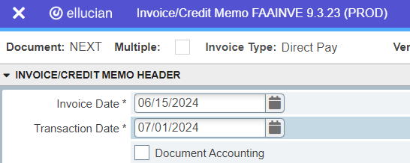

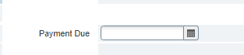
- To determine the payment due date, use the Prompt Pay Due Date Calendar Guide found here: https://adminfinance.umw.edu/ap/direct-paycheck-requests/prompt-pay-due-dates/

Questions on Prompt Pay can be directed to payables@umw.edu

!Note: The last check run for this FY is 6/24. Invoices due between 6/24 and 6/30 are included in the last check run. Ensure all receipts are in the hands of Accounts Payable as early possible and at least a week before the 24rd.

