PRIOR/NEW YEAR EXPENSES FOR CREDIT CARDS
Expenses paid by credit card on the first two FY21 billing cycles (see tables below) of the SPCC and the UMW Finance Card need to be evaluated to determine if the expense is related to the prior fiscal year (FY20) or the new fiscal year (FY21).

REASON: For the months of July and August, all expenses—including expenses on credit cards—related to prior fiscal year must be recorded in the prior fiscal year for financial reporting to Richmond. Cardholders must evaluate their credit card transactions for the July and August cycle end dates and enter PRIOR in the location field in WORKS if the expense is related to FY20. Cardholders will leave the location field in WORKS blank if the expense is related to FY21. The cash will come out of FY21 budgets; however, for financial statements, the expense is required to be recorded in FY20 as an FY20 expense.

SPCC Month | Cycle Start Date | Cycle End Date | Works Statement Available | Sign Off Deadline | Add PRIOR to the GL Location code in Works if the goods were received or services were performed on or before June 30.
July | Jun 16 | July 15 | July 17 | July 22
August | July 16 | Aug 14 | Aug 16 | Aug 24

UMW Finance Card Month | Cycle Start Date | Cycle End Date | Works Statement Available | Receipt Packet Due to Debra Cash in Accounts Payable | Add PRIOR to the GL Location code in Works if the goods were received or services were performed on or before June 30.  Does not apply to 8 funds.
July | Jun 26 | July 24 | July 28 | Aug 3
August | July 25 | Aug 25 | Aug 27 | Sept 2

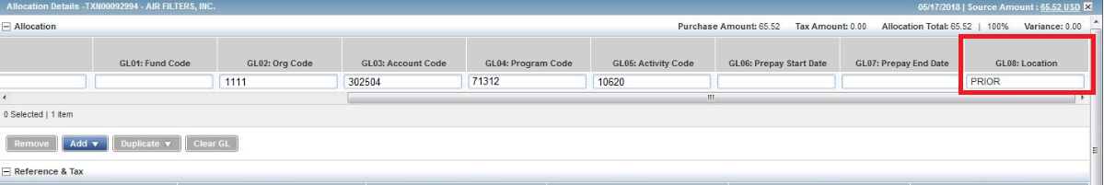

Questions to ask yourself to determine whether the expense needs to be captured for the prior fiscal year (by entering PRIOR in the location field in WORKS) or the new fiscal year (by leaving the location field blank in WORKS):

FOR GOODS
Was this payment for a good that was received prior to July 1st?
- If NO, then leave the location field blank in WORKS
- If YES, then enter PRIOR in the location field in WORKS
- If the goods were received in different shipments on various dates, by what date was the majority of the goods received?
  - If this date is PRIOR to July 1st, then enter PRIOR in the location field in WORKS.
  - If this date is on or AFTER July 1st, then leave the location field blank in WORKS.

FOR SERVICES
What date was the final date of service received?
- If this date is PRIOR to July 1st, then enter PRIOR in the location field in WORKS.
- If this date is on or AFTER July 1st, then leave the location field blank in WORKS.

FOR SUBSCRIPTION/MAINTENANCE AGREEMENTS
How much of the service (for that particular invoice) falls in the prior fiscal year?
- If the majority of the service falls prior to July 1st then enter PRIOR in the location field in WORKS.
- If the majority of the service falls on or after July 1st, then leave the location field blank in WORKS.

Examples: Subscription runs from 5/2020-4/2021 New year expense
Maintenance agreement 7/2020-6/2021 New year expense
Maintenance agreement 11/2019-10/2020 PRIOR year expense

Examples with Invoices
Professional Building
Invoice received 6/19/2020
Service Received 5/19/2020
PRIOR year expense (enter PRIOR in location field in WORKS)

bePress
Invoice received 6/29/2020
Subscription runs 6/28/20-6/27/2021
NEW year expense (location field is left blank in WORKS)

Dell
Invoice received 6/19/2020
Goods received 6/19/2020
PRIOR year expense (enter PRIOR in location field in WORKS)

Instructure
Invoice received 7/7/2020
Subscription runs 8/2020-7/2021
NEW year expense (location field is left blank in WORKS)

Quarles
Invoice received 7/13/2020
Goods received 7/11/2020
NEW year expense (location field is left blank in WORKS)

Quarles
Invoice received 7/13/2020
Goods received 6/29/2020
PRIOR year expense (enter PRIOR in location field in WORKS)

If you are still having difficulty determining whether the PRIOR location code should be used please give Accounts Payable a call and we will be happy to assist you.

Leigh - Ext 1226
Debra - Ext 1225
Tyra - Ext 1030

