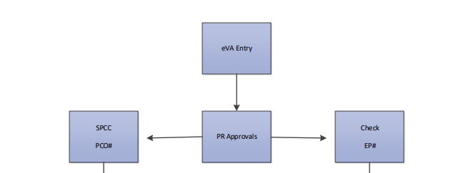

Approvals viewed on a Purchase Requisition
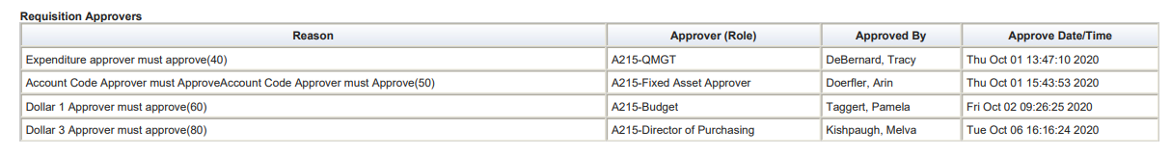

Buyer Approval is required for: vendors who do not accept electronic orders and orders placed on your behalf with use of your credit card:
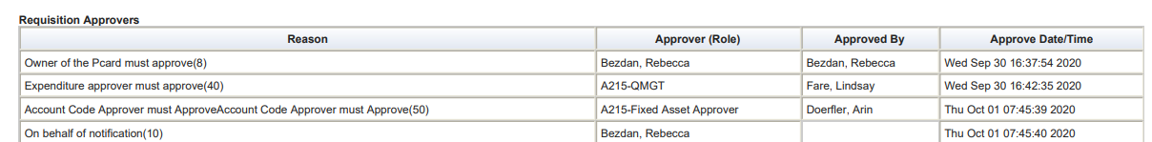

From Leigh Penn, when you use the Gold Card, Lpenn will typically look for the contract number within the PR prior to approval.

Approval Overide for TSRC Contracts and message is auto printed in Comments section:

Approvals for eVA Change Orders follow the same path. When editing the change order, add information into the Comments section to let the Approver know what has changed. Change orders are usually manually entered into Banner by TESS dept due to different manners of handling version changes.

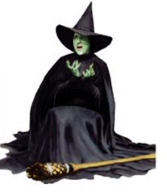
PO Version numbers do not feed in2 the download.

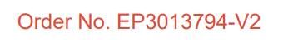

UTube video on entering Change Orders: https://www.youtube.com/embed/9Tof0XZEylQ?rel=0

Questions and Comments??

When Requisitions are Denied….

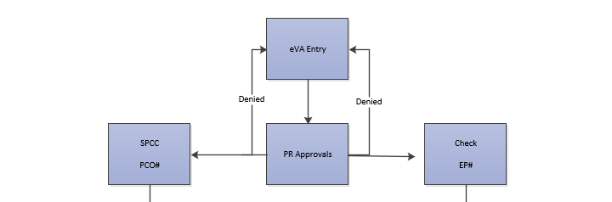

Purchase orders requiring edits are Denied in eVA by the respective Approver and returned to the buyer. Approvers use the Comments section to provide guidance:
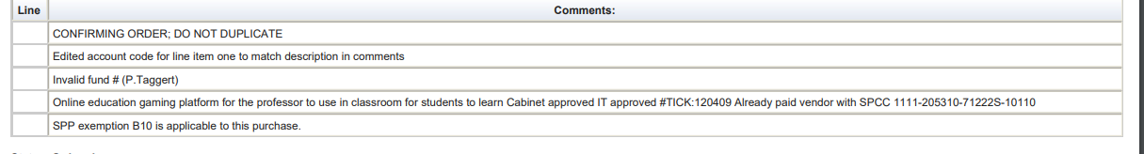

When an order is Denied,
Users receive notification via Outlook. Once logged into eVA, you will be on the landing page or land on the Portal. Once on the requisition, scroll down to view Comments for guidance on edit requirements.
Choose Withdraw to retract and delete or save the order for later (maybe the devil made you do it), or Edit to adjust and resubmit for Approval.

Arin denies all the time for the following: Incorrect Fixed Asset Code, 7 expense code incorrectly, lack of descriptions,….
Because we are working in two systems, our Banner, which is version 9, can create multiple problems across the various departments in Business and Finance if we are not careful with data and reporting needs.

Outlook Notifications
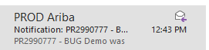

Login to eVA and land on the eMall Summary Tab….sometimes. Other times I would land within the Portal then navigate to the eMall.

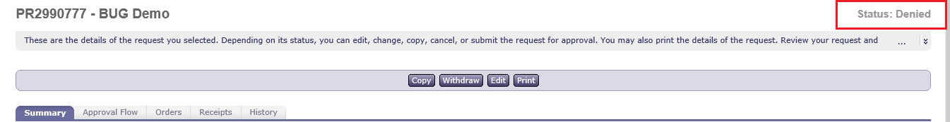
Summary Tab Comments

When navigating in the eMall, scroll down to window titled Requisitions Submitted this Month in Denied Status

Requisition Tab views:
Approval Flow Tab
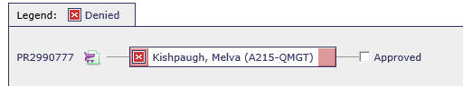

History Tab
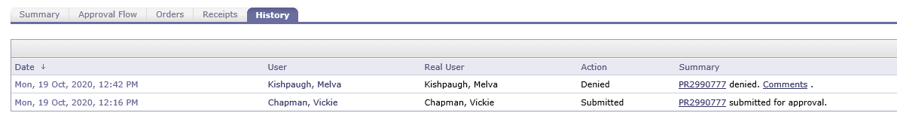

When we come back, Glenda the good witch will provide a few treats..

