Buyer Examples of prepay coding within eVA and Works
Updated Prepay Table https://adminfinance.umw.edu/ap/pre-payments/

Example 1: Use of eVA and Descriptions Area on line item for yearly subscription/membership
This order has detailed information on what is being purchased and includes prepay discussed last meeting:
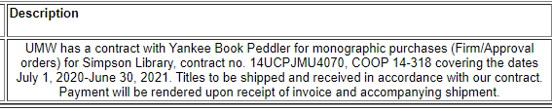

Reminder, there is a new account code on pre pay table for memberships realted to software purchases- use 71275 or 72218L, NOT 71221. See the prepay table for additional information.
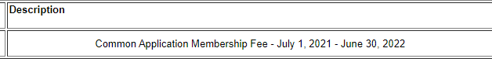

Example 2: Prepays in Works for yearly date ranges are entered on GL 06 and GL07
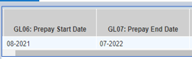

Example3: Prepay entered as 13 months in Works.
The below entry is for a 13 month date rante, not acceptable to Department of Accounts. If the Start Date (GL06) and the End Date (GL 07) have the same month, that always equals 13 months in Works:
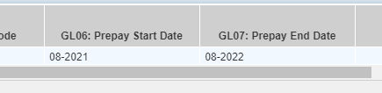

Example 4: Prepay entries for mid month date ranges in Works
Those tricky yearly subscriptions/memberships that run mid month, lets say 8/14/2021-8/13/21 would be entered as below. Drop a month off the Prepay End Date on GL07 to show a 12 month period of time.
When the Prepay Start and End dates are less than a year, lets say 1/15/22 to 03/15/22, that’s alittle easier to understand and document.
