Login to eVA

Open the **Go To** menu option and select *Report and Resource Center* from the drop down

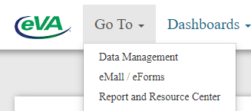

Within the **Reports** tab, select the report *100 Vendor data by NIGP code*

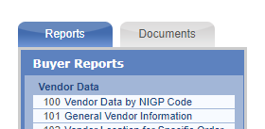

Looking for one supplier’s email address / contact info: select “I want data for one vendor.”  Then select “vendor name” and enter it in the blank.

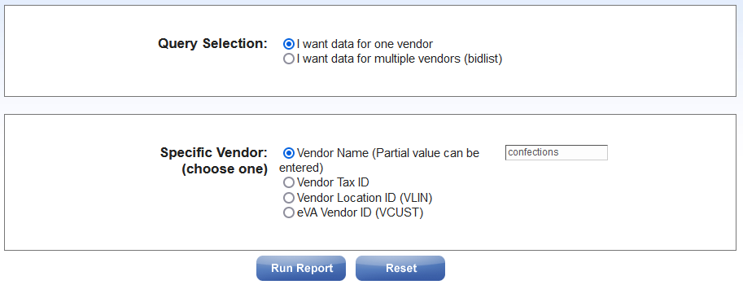

If you have the eVA Vendor ID from the eVA Transparency Report (Vendor database listing), you can enter it instead of a partial name, otherwise you will receive a report that lists every supplier in the database whose name contains your keyword.

cid:image003.png@01D7C116.AE3020F0

Search results:

