How to Create a Digital Signature in Adobe Reader & Acrobat

To create a digital signature that can be applied to PDF forms, please follow the instructions below:
- Open a PDF Form that requires a signature. This is denoted on a PDF form by a red tag that looks
like this.

- Double click on the signature field.
- You will be presented with a window labeled “Configure a Digital ID” for signing.
- Select “configure new Digital ID.”
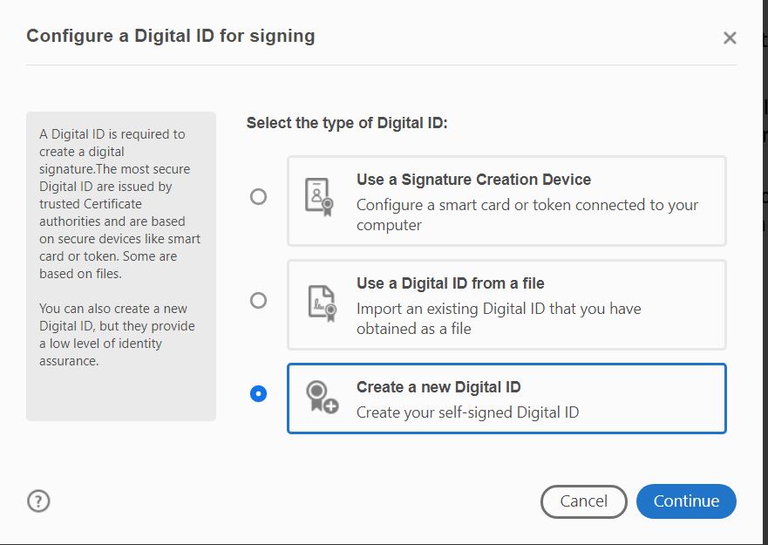
- Select “Create a new Digital ID”

- Select the destination for your Digital ID. There are two options and either is acceptable.
- Save to file. Complete step 9 to create your PIN (below).
  - Creates a Digital ID which requires a PIN each time you digitally sign a document. The digital signature is saved locally to your computer.
*note: if you forget your PIN you cannot retrieve it. You will need to create a new Digital ID*

- Save to Windows Certificate Store.
  - This option does not require a PIN when digitally signing a document and is saved to the Windows Certificate Store.
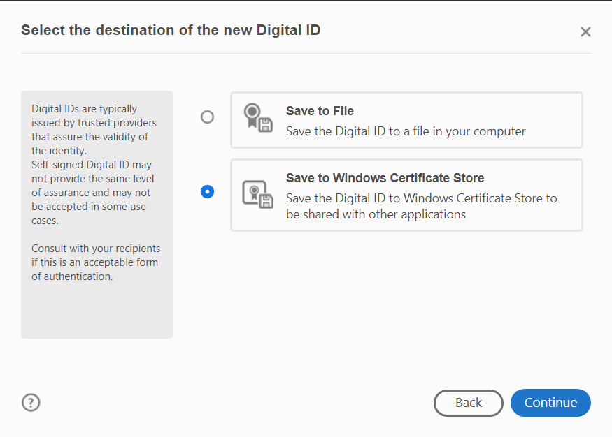

- Enter your information in the Name, Organization Unit (department), Organization Name (UMW), and email fields then select “Save”.
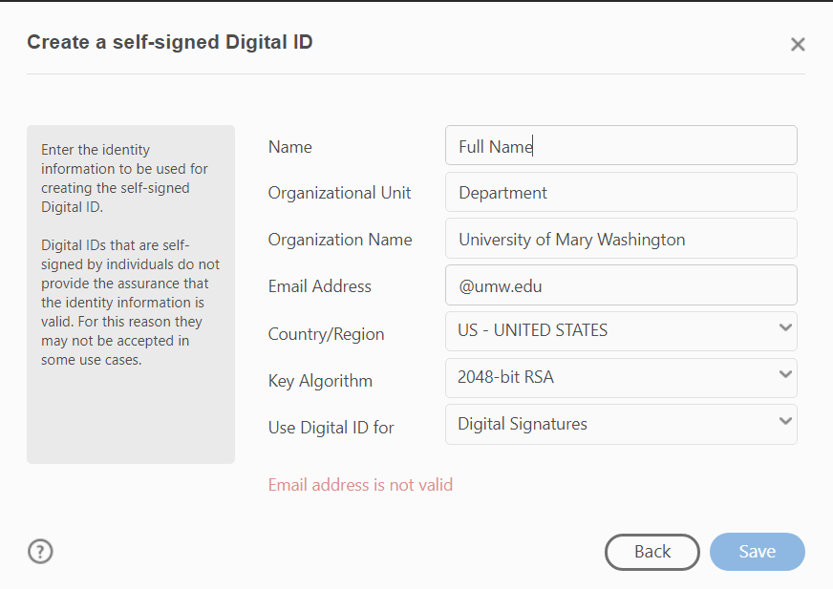
- Next you will see a preview of your new Digital Signature. Select “Continue”
- If you chose “Save to File” (create a PIN) you will choose a location for your file as well as a PIN for your digital Signature.
- Enter a PIN you will remember.
*If you forget your PIN, you will not be able to recover it. You must create a new Digital ID with a new PIN*
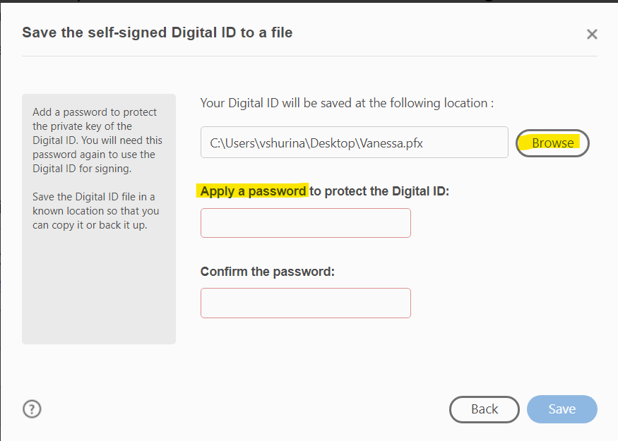

- Select “Save.”
On the next screen you may select “Continue” to apply your digital signature to the document.

