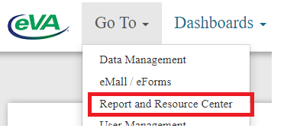
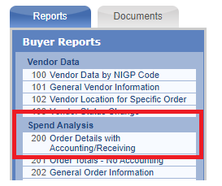
Query Selection: Multiple Orders
Select Date: Custom.
Calendar From and To: Enter 1 year at a time 1/1/20-12/31/20 and 1/1/21-12/31/21)
Order Source and Vendors: Check All
Optional Selection Criteria: Enter the Requester User ID
Value: Enter your user name
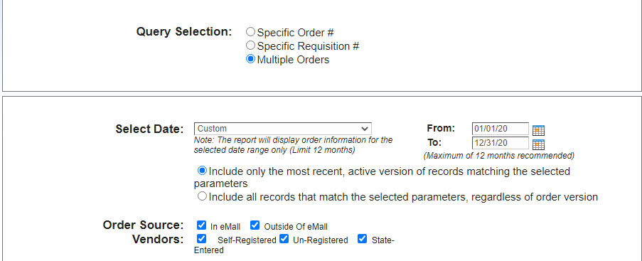
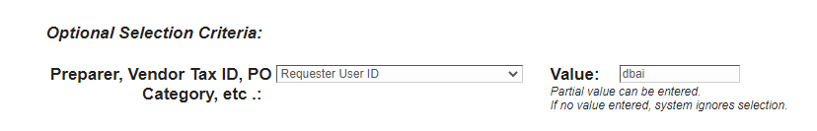
Leave all defaults on the rest of the repot and choose Run Report at the bottom of the page.
eVA will provide a list of all orders for the time period. Download the report (PDF, Excel or CSV) and rerun the report for year 2. Save the reports for NextGen migration confirmation.
