Change Orders

Summary: Change Orders are initiated on the Purchase Order. Each change will create a new Requisition number. Requisitions are used to for duplication purposes, not for change orders.
Change Orders are amendments to the original order and historically posted on each order as changes occur. For historical review, it is important that each change contain accurate, detailed description of what is edited on the order.
Note! EP change cannot be entered on converted orders from the old eVA system, however, PCO orders can be changed. Please contact TESS for assistance.

Procurement>Browse Orders
- Locate and select the order which requires a change. 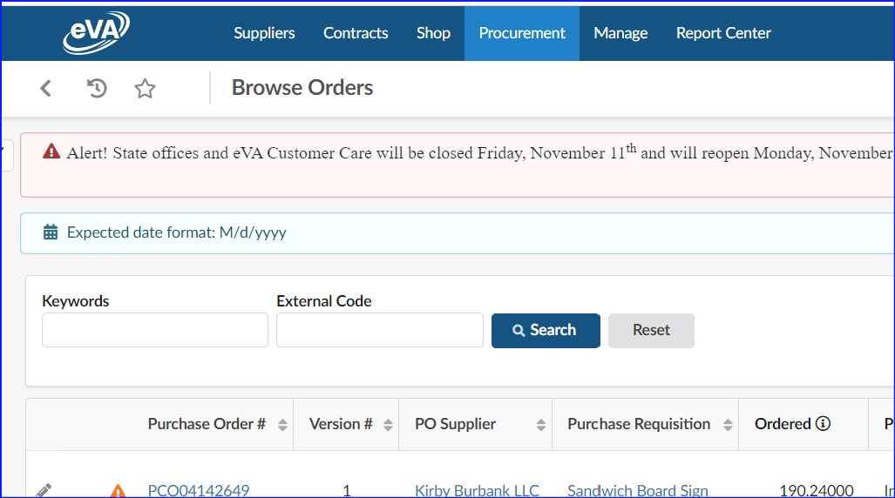
- Select the Change Order button.

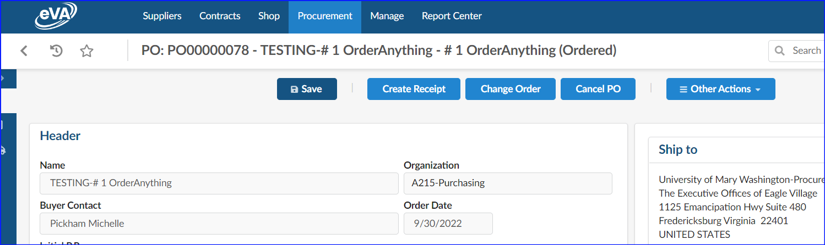

Change Order Window
The Significant Change Request and the Amend# will default. The first change the order will be Amend#1. The Amend number(s) will show on the purchase order once the order is fully approved.
- Change Type(s): Use the dropdown menu to select the reason for the change order.
- Description of Changes: Enter additional information on the change requirement, be as specific as possible. If changing FOAP, please indicate the new FOAPAL. This description is not visible on the printed order but is visible to approvers and suppliers.
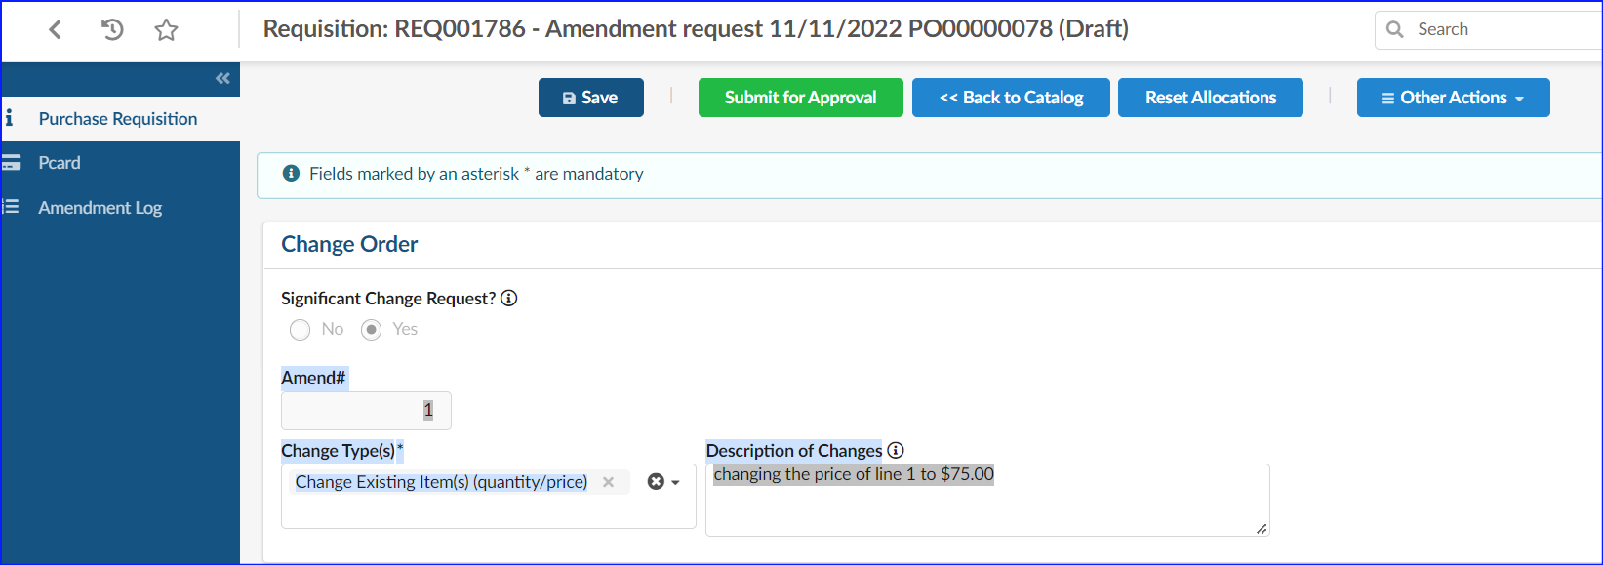
b.
a.
- Select Save
- Edit your order as needed
- You may use the Messaging feature to further comment to the Approvers
- Select Save
- Click the Submit for Approval button after you’ve reviewed your changes and added messaging.
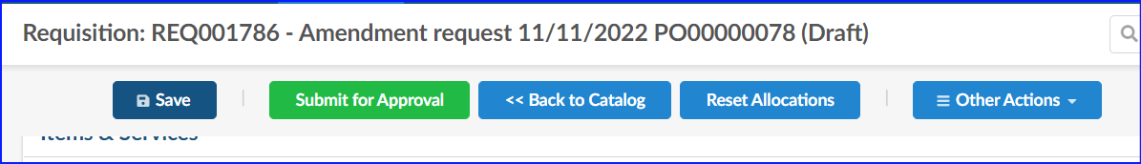
All Purchase Order changes (amendments) are tracked on subsequent Change Orders. Buyers and Approvers can open any amendment to drill down on past amendments, which will show as Cancelled when opened.
