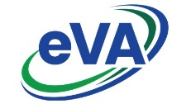
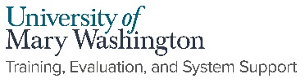
eVA 200 Report
Run the eVA 200 Report by accessing the Report Center. Compare the data with the 200 report you saved prior to NextGen eVA. If you notice any discrepancies, or cannot access the Report Center, email tess@umw.edu.

- Click on Report Center located on the top menu bar.
- Click Access Report Center. You’ll be directed to the Report and Resource Center. To return to your eVA dashboard select Return to Portal.
- Follow the instructions below to run the 200 report.

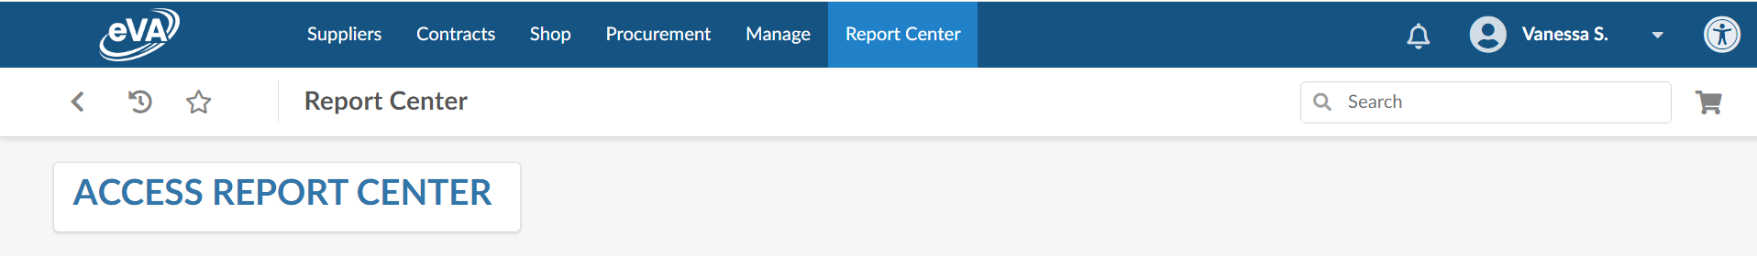

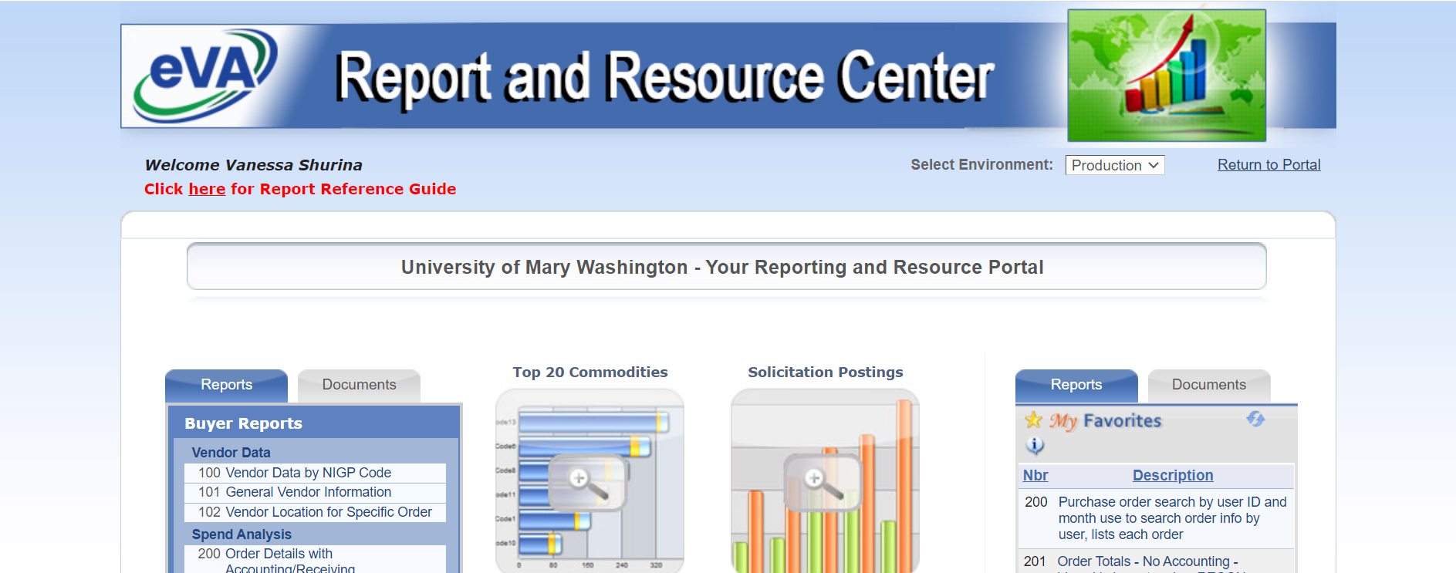

How to run the eVA 200 Report:
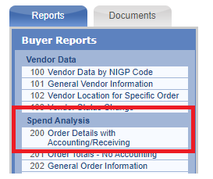
Query Selection: Multiple Orders
Select Date: Custom.
Calendar From and To: Enter 1 year at a time 1/1/20-12/31/20 and 1/1/21-12/31/21)
Order Source and Vendors: Check All
Optional Selection Criteria: Enter the Requester User ID
Value: Enter your user name
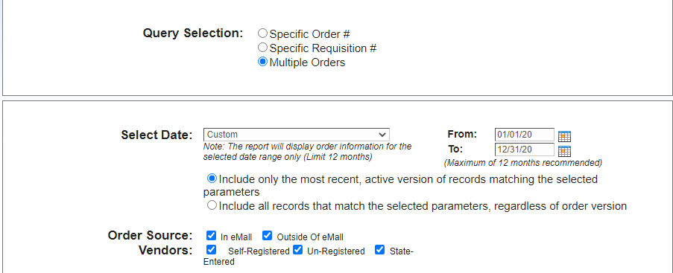
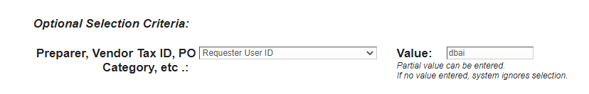
Leave all defaults on the rest of the report and choose Run Report at the bottom of the page.
eVA will provide a list of all orders for the time period. Download the report (PDF, Excel or CSV) and rerun the report for year 2.
