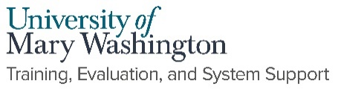

Creating a Non-Catalog Requisition

- Select Procurement>Create Requisition the top blue menu bar.

Header Window

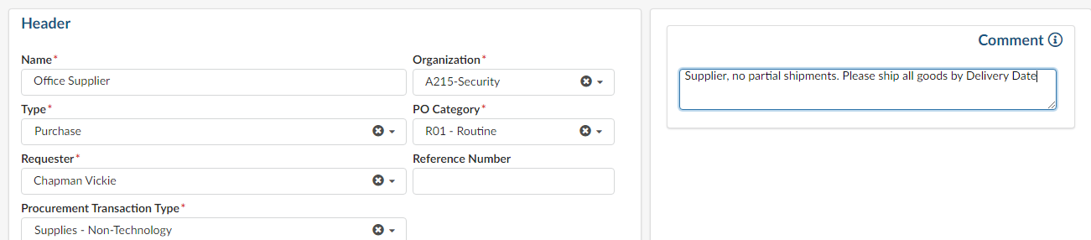
  - Name: Insert a Title that is meaningful to you. Adding today’s date is helpful for tracking.
  - Type: Defaults to Purchasing.
  - Requestor: Defaults to your name.
  - Procurement Transaction Type: Use the dropdown menu to select the best description of your goods or services
  - Organization: Defaults to your grouping within eVA. Do not change this field.
  - PO Category: Use RO1 for Routine Order unless instructed otherwise by Procurement.
  - Reference Number: This is a searchable field you may use as needed. If re-opening an EP from “old” eVA, enter the EP number in this field. This will help track the new order.
  - Comment: Use this field for all Supplier communications. It is helpful to enter your FOAP in Supplier comments for viewing on the printed order. The FOAP is not relevant to the supplier, however, be mindful when entering additional information in this field.
  - Click the Save button.

The Save Button will:
  - Expand the window view to include the default of Ship to and Bill to. You may change the Ship To field by use of the drop-down menu.
  - Open the Header Field 1 dropdown options to indicate payment method.
**Note! These options are used to communicate payment method internally. This does not replace adding the PCard to the order. You will need to add your Pcard manually
using the blue side menu.
  - Choose from the following:
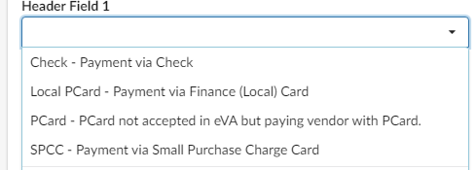

  - Click the right arrows to expand the blue menu bar. Click the Pcard icon to add your Pcard to the requisition.
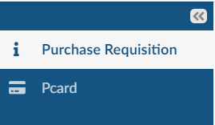
  - Alerts and Messaging feature available by selecting the orange triangle on the right side of your screen. Within the Add a Message feature, Approvers and Buyers can send messages to each other for the specific purchase order needs. Messages are not viewed by Suppliers nor visible on the purchase orders itself.

  - Click the Save button. Scroll down to Items & Services.

Item & Services
Select Add Line to open the Item Details Window.

- Item Description
- Product Type: Defaults to Product. Drop down selection includes Freight, Shipping and Services
- Detailed Description: Enter the detailed description of your item
- Commodity: type in word, code, or use the dropdown to find the commodity that best describes the item.
- Delivery Date: Select the date for delivery. If services were selected in Product Type, use the From and End date.

- Estimate Costs
Quantity: enter the quantity, then scroll up to enter price.
Unit Price: Enter price of good or service.

- Suggested Supplier
Supplier: Type in the name or use the drop-down menu to select the Registered Supplier.

For faster searching: Choose Select All to view all suppliers then filter down as needed. You may also use the favorites filter to view all your favorite Suppliers. To choose a Supplier from the list select the check box beside the supplier name

- Internal Additional Details
External Contract Number: Enter the UMW contract Number. This field is required.
Click Save.
NOTE: The contract number must be entered on each individual line item. The mass edit function is not working at this time.

- Allocations
- Scroll down the Allocation field to Enter the Fund, Fiscal Year, Organization Allocation, Program Allocation and Account. Click Save and Close
***To split FOAP an Allocation, use the +Allocation button to split by % or Amount. Click Save and Close.**
- You will be returned to the Requisition Header where you may copy or edit line items.

- To copy a line item, select the check box beside the line item you’d like to copy. Select Copy Selected Lines button. It is beneficial to copy line items when possible. Copying a line will also copy the supplier and FOAP.
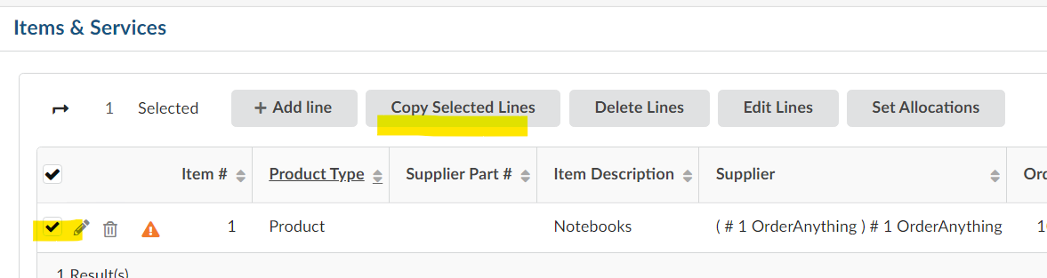

- Click Save then Save and Close. You will return to the purchase order Header window options.
- You may use the Set Allocations button to edit allocations for multiple line items at one time.
- Reset allocations will clear allocation information for the selected line(s).
- Scroll down to Attachments.

- Attachments

  - Click on the New Document Button If you would like to add an internal attachment and/or an attachment for the supplier.

  - Select document type

Title Window: enter the name of the document. Title will be visible on the purchase order.
Information Window: Select the Click or Drag to add files to select your document
  - Click the Save and Preview button and then Close to return to the PO Header.

Internal Comments Window
- Enter your procurement quotes, coding, approvals and messaging.
- Click the Save button

Review your Order Prior to Submission:
- Use the print icon located at the top right corner of the window to view the order. You may also use the eVA 203 report found in the Report Center to print a detailed copy of the requisition.
- Use the Workflow Preview & Ad hoc button to view the approval flow.
- Select the Pcard icon on the left blue menu bar to ensure your pcard is selected for appropriate pcard payment orders.
- If using the Messaging function, send the message before selecting the Submit for Approval button.

