Punchout Catalog Orders
Summary: The purchase order is created within the catalog first, then the order is brought into eVA once the check out is complete. Punch outs will not allow change orders, nor can the requisition remain in draft status. Once the catalog is exited, additional items will require a new requisition.

Search for Catalogs
- Select Shop>Search Products using the top menu bar or use the Search for Products field on the Home Screen.
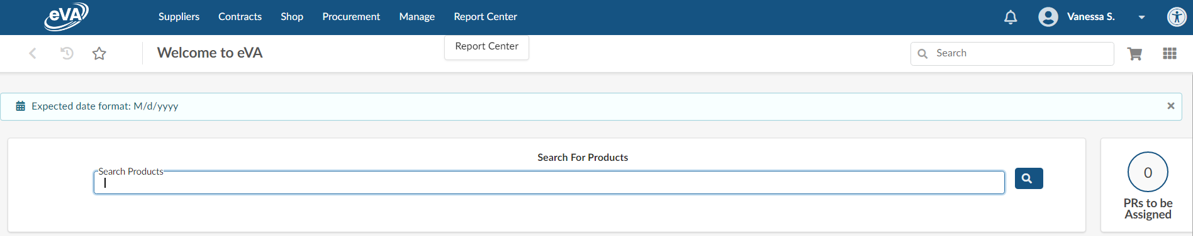

The example below uses the TSRC Catalog via the Search Products field located on your dashboard.
!Note Once the catalog is exited, you cannot direct back to the catalog for changes. You will need to withdraw the Requisition and create a new Requisition. **Contact Procurement or TESS to discuss changes to catalog purchase orders.
b. Enter “TSRC” in the search box and click the Search icon.
c. Scroll through the list of options. Choose TSRC for UMW by clicking on the shopping card icon.
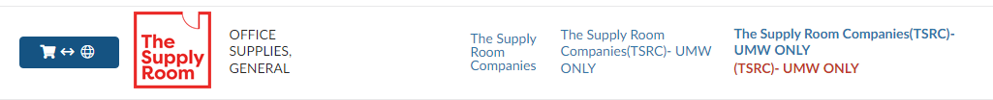

- Add your selected items to the Cart. When all items are selected, click the Submit Cart found at the top right of the TSRC catalog page. You will be directed from the TSRC catalog into the eVA requisition.

Header Window
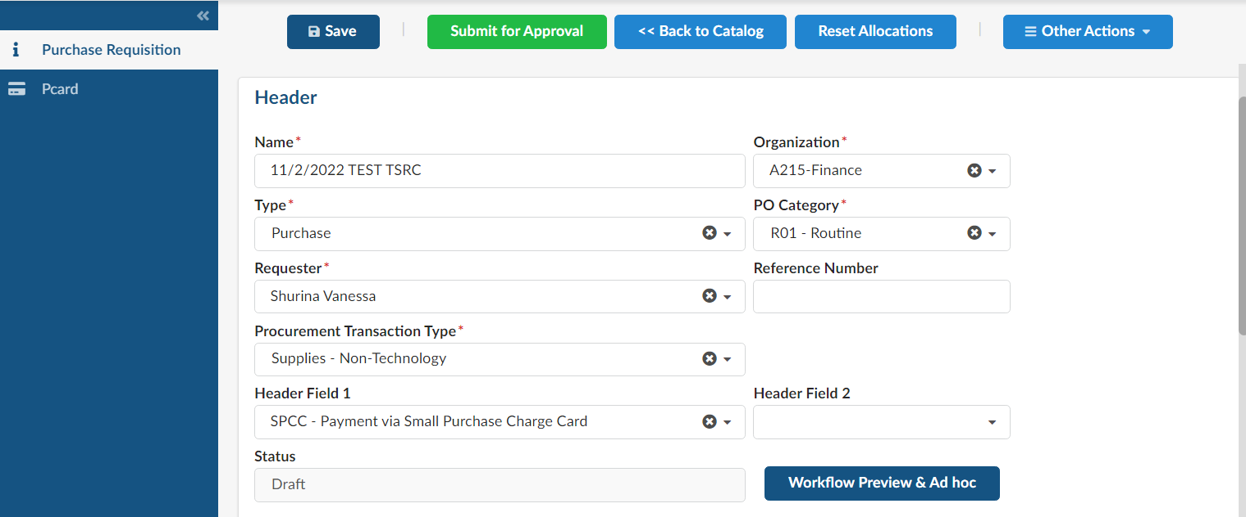
Enter Supplier comments here. Scroll to the far right, under Ship To and Bill To

  - Name: Insert a Title that is meaningful to you. The date is populated, we suggest leaving this for easier searching later on
  - Type: Defaults to Purchasing
  - Requestor: Defaults to your name
  - Procurement Transaction Type: Type in Supplies and choose the appropriate category or use the dropdown menu
  - Organization: Defaults to your grouping within eVA
  - PO Category: User RO1 for Routine Order unless instructed otherwise by Procurement
  - Comment: Enter specific comments to the Supplier here
  - Add your Pcard: Use the blue left-side menu to select your Pcard. Click Save, then choose the Purchase Requisition option on the blue side menu to return to the PO Header.
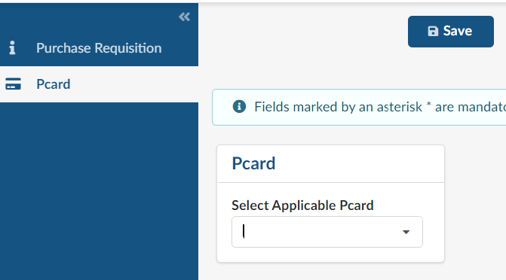
  - Header 1 Field: Choose the appropriate payment method for this order. Note: this field is for internal communication only and does not replace adding your Pcard to the order.
  - Click the Save button and scroll down to Items & Services

Items & Services
Items you’ve selected from the Punchout catalog will be listed here.

Allocations
- Select the checkbox in the Item# column to select all line items.
- Select Set Allocations to apply the same FOAPAL to all line items. The Set Allocations window will appear.
- Click the +Allocation button
- Add the FOAPAL by typing the digits. You do not need to use the dropdown menu. If you would like to set allocations individually for each line item, click the pencil icon to edit each item induvidally.
Note: the fiscal year is NOT always populated. You may need to manually enter this field by typing 2023, or current fiscal year.

- Click Apply and Close to close the Allocations window.
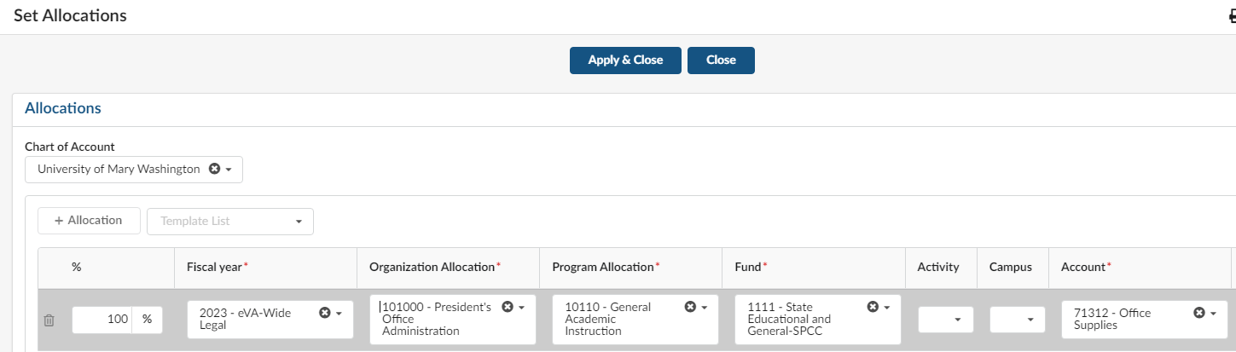

Mass Editing Line items
Currently this feature is used to add a Delivery Date, additional options may be available with future enhancements.
  - Select the checkbox in the Item# column to “select all”. Click Edit Lines to apply mass updates to all items, for instance the addition of Delivery Date.
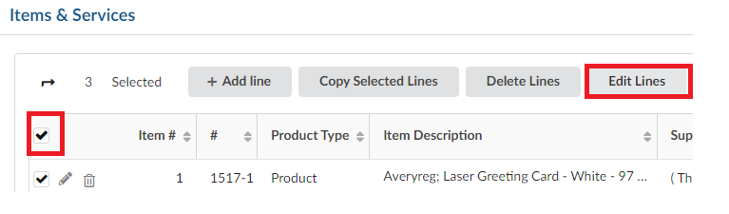

P.R. items mass update Window

    - Scroll down the Item Mass update Window and to choose the Delivery date field. Enter the date and ensure the Add button is selected.
    - Click Save, then Save & Close. You will be directed back to the Requisition Header.
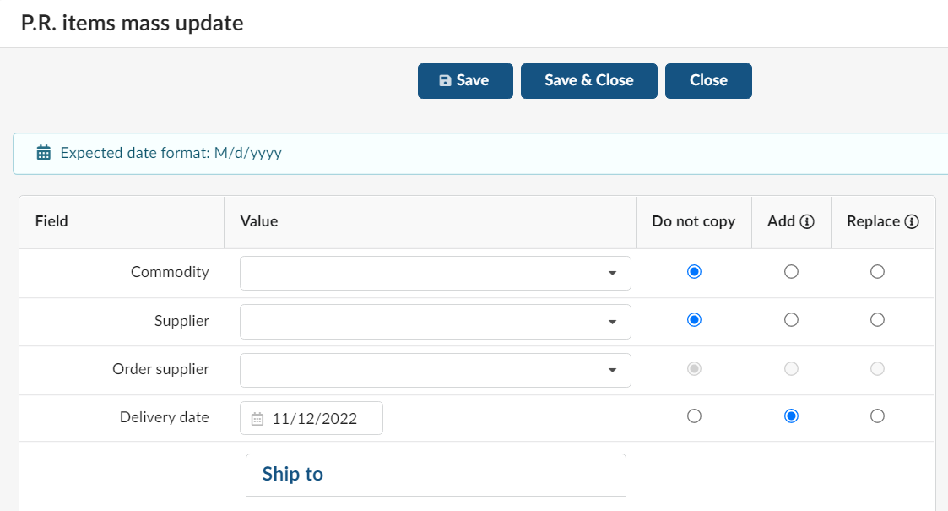

Internal Additional Details
- Enter the catalog contract number within the External Contract Number field. This must be added for each catalog and punchout line item until further notice.
- Click Save, then Save and Close for each line item.
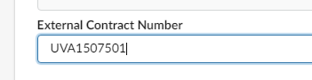
- Once all items have been edited, review the order and Submit for Approval.
