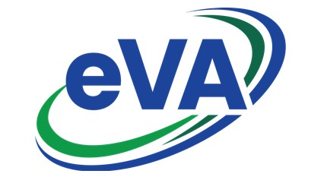
Searching and Favorites
Searching for Requisitions, Orders and Suppliers begins by using the corresponding menu located in the top blue menu bar. The Favorites function is used to bookmark your frequently used Suppliers, eVA pages and Requisitions.

Requisitions
  - Navigate to the Procurement menu, select Browse Requisitions.
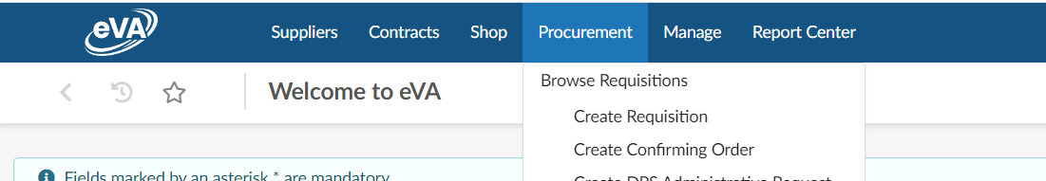

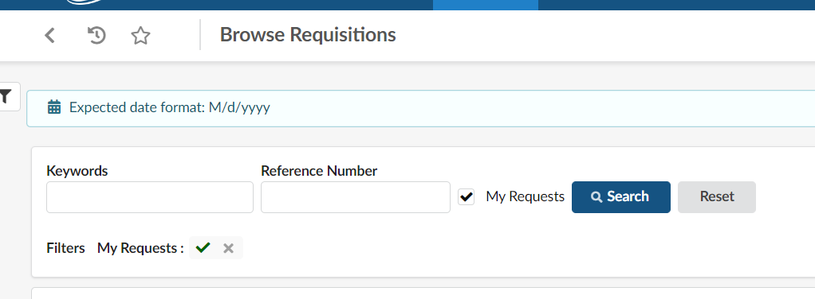
  - To view your Requisitions select the My Requests check box.
  - Click Search.
  - A list of all requisitions containing your name as the Requestor will appear.

Note! If you place an order on behalf of another User AND change the requestor to their name, the requisition/order will not appear under your requisitions/orders. You will need to search using their name as the Requestor.
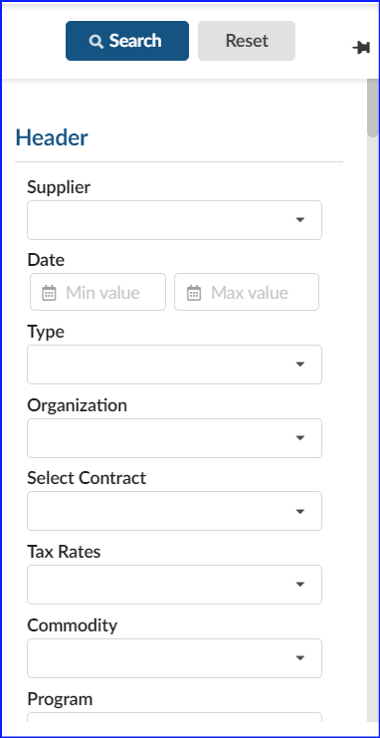
  - Enter keywords to execute a broad search. Click Search.
  - Click the funnel icon to open the advanced filter.
  - Additional search options will appear. Ie: Supplier, Order Date, Requestor, Type (purchase/confirming), Status (draft, in progress, rejected, etc.)
  - Click Search.
Note: as you select filter options you will see a list of all filters applied to the search. Click Reset to clear all filters or the X to remove individual filters.
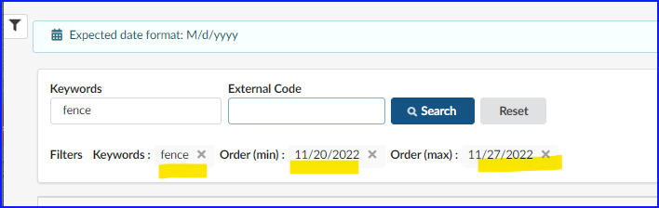

Orders
Once a requisition is fully approved it becomes an order containing a new numerical value with a prefix of PO (non-credit card order) or PCO (credit card order).
  - Select Browse Orders from the Procurement menu.
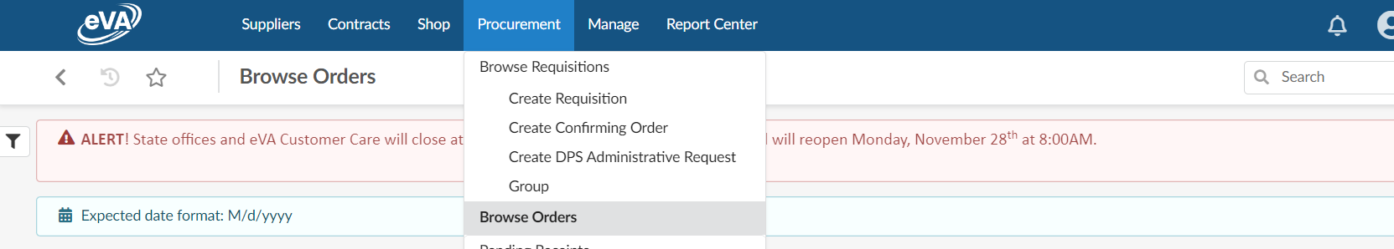

  - You may enter Keywords, or the order number.
  - The External Code field is used to search orders converted from the previous eVA system. (ie. EP1234567)
NOTE: Orders entered 24 months prior to November 2022 converted into NextGen eVA. They are searchable by the old EP or PO number. If the order is older than 24 months the order can be viewing using the 200 report in the eVA Report Center.

  - Select the funnel icon to expand the advanced search box. A list of searchable fields will appear. You may search by Order Date, Requestor, Supplier, Status (ie. draft, rejected, ordered).

Note: as you select filter options you will see a list of all filters applied to the search. Click Reset to clear all filters or the X to remove individual filters.

Suppliers
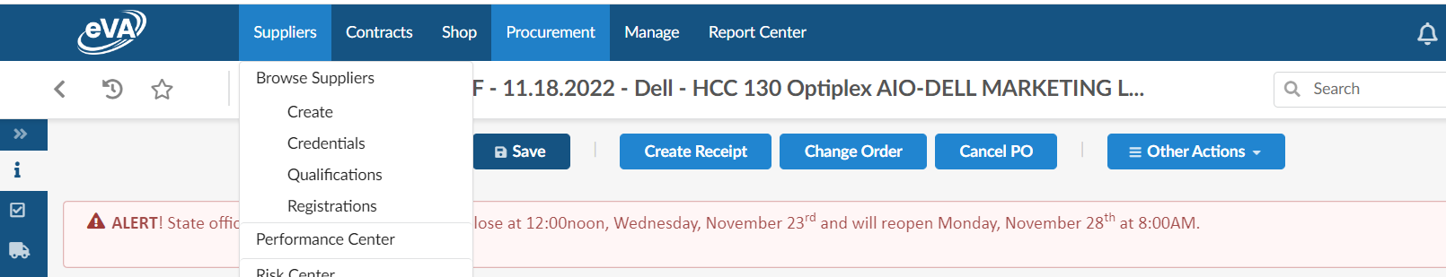
- Select Suppliers > Browse Suppliers from the top blue menu bar.
- Enter Keywords or select Favorite Suppliers to view a listing of Suppliers you added as favorites.
- Select Search.
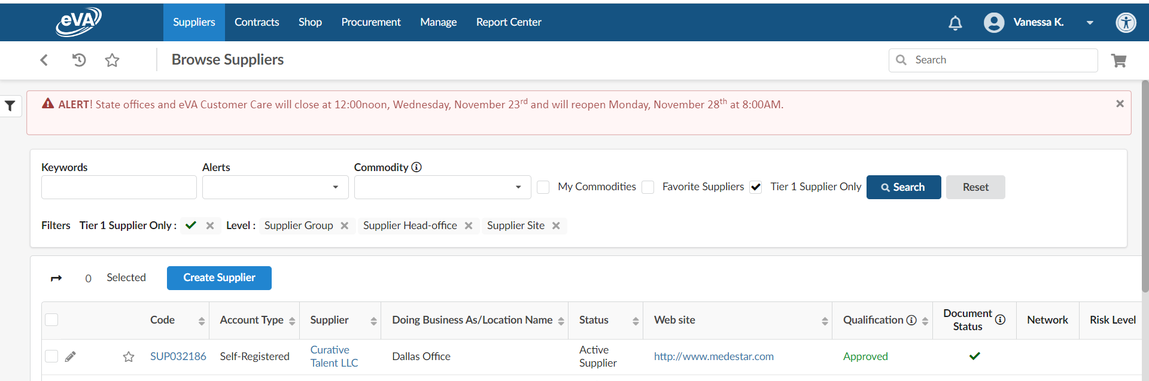

- You may add your supplier to Favorites by clicking the star icon to the left of supplier code. Additional information about the Supplier can be accessed by clicking the Supplier name.
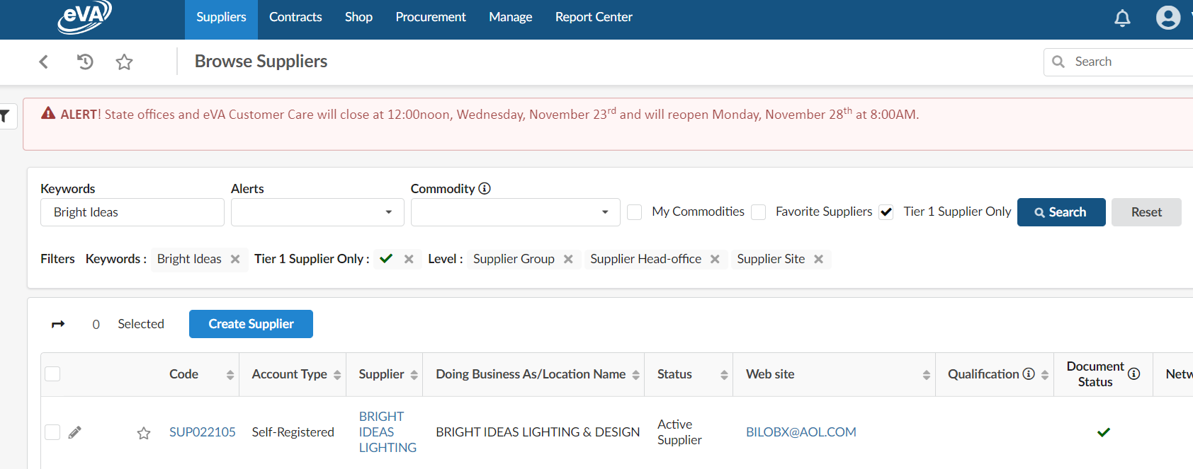
- By clicking the Supplier name a new page will appear .The left blue menu contains company information, contacts, documents & certs (ie W-9), and addresses. To return to the search results select the < arrow,
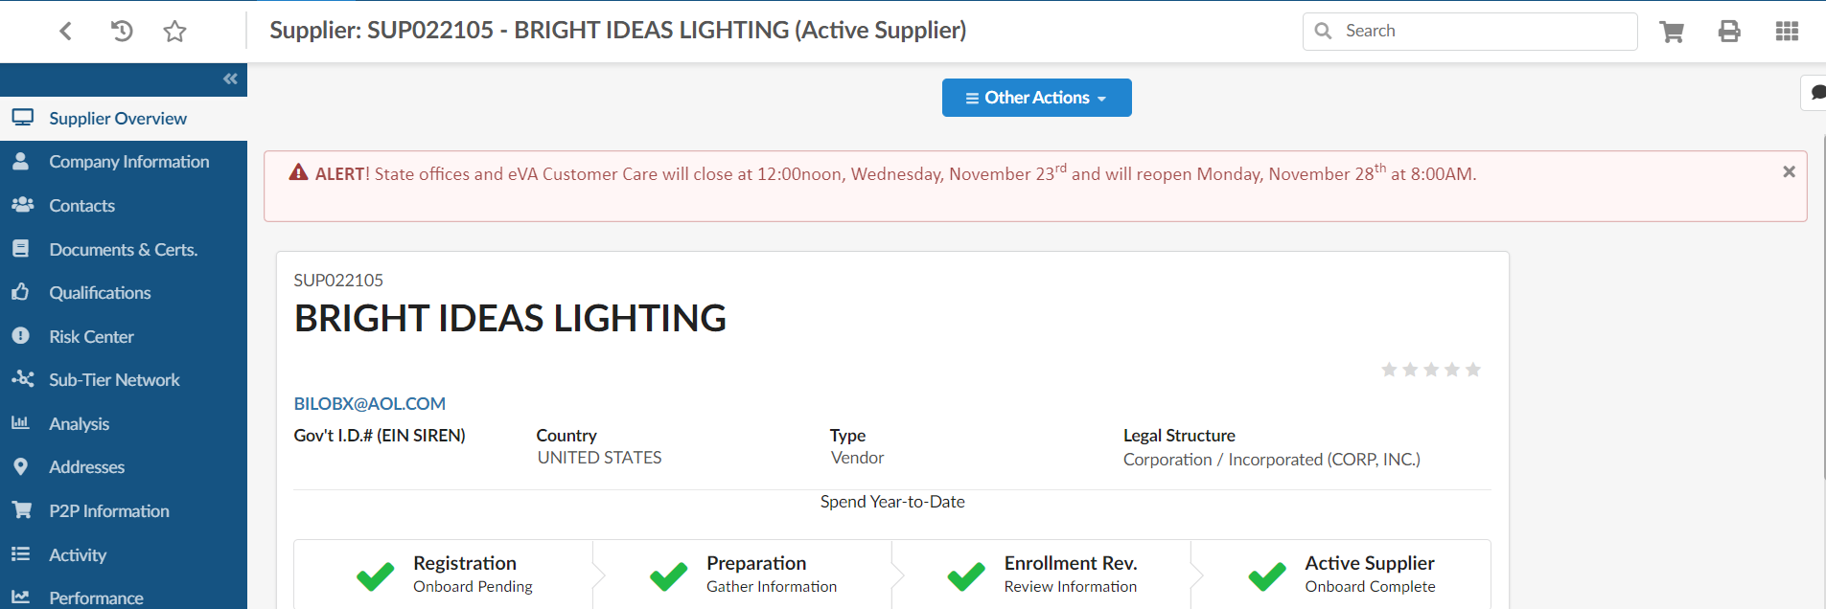

4. Favorites
The favorites feature is used to bookmark favorite Suppliers, Catalogs, and Requisitions you commonly use.

  - Supplier
      - Use the search method as described in Supplier Searches to identify your Supplier. Click the star icon to add the Supplier your favorites.
      - Your favorite suppliers can be viewed under the Supplier> Browse Suppliers menu and selecting Favorite Suppliers.
        - Favorite Suppliers are also visible in the Supplier field within the line item of a Requisition.
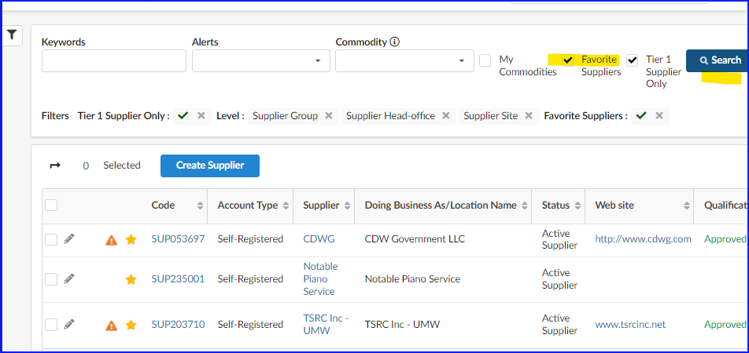
  - Requisition – it is helpful to bookmark requisitions frequently referenced or copied.

      - Locate the requisition by using the Requisition Search procedures.
      - Click the Star icon.
      - Add page as favorite. Edit the title of the requisition or click Add page to save as a favorite.
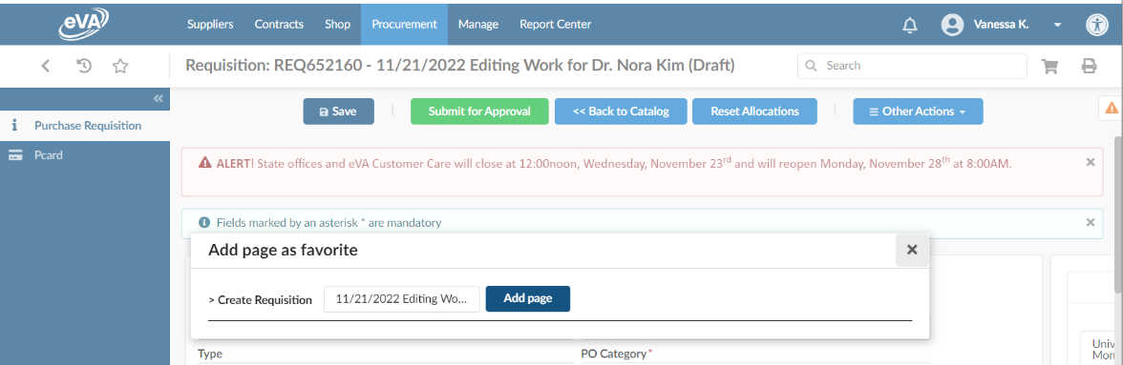
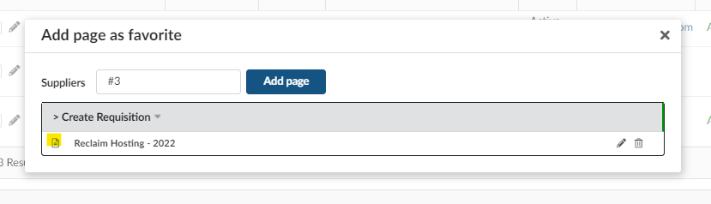
Note: To view a listing of all bookmarks click the Star icon beneath the eVA logo.

