Login to eVA and select the Report Center form the top blue Menu bar
Select Access Report Center
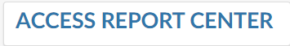
Under the Report tab, in the Buyer Report headings, click on the 203 – View or Print Orders and select Open
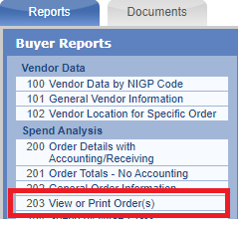
Choose Specific Order # and enter your PCO or PO number. (Requisition view is not yet available)
Checkmark Include All Versions on the Order then Run Report
