eVA Review and Approvals- Draft
Login to eVA and click on your name on the top right of the form 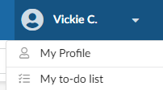
Select My To Do list from your personal menu or you may use the My to-do list form the eVA home page.

Open the Requisition for view by clicking on the Title of the Requisition, as seen in the Object Column or the Requisition Number as seen in the # Column
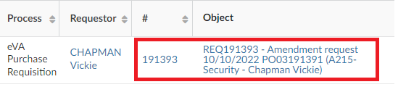

An open Requisition for Approval will show the Requisition Number, Title and left blue menu bar. Begin your review within the Header window to view the mandatory fields of Requisition Type, PO Category and Purchase Order Transaction Type. Header field 1 may be populated with payment type.
The Pcard is validated in the blue side menu. Select Pcard to view if the card was selected for payment.

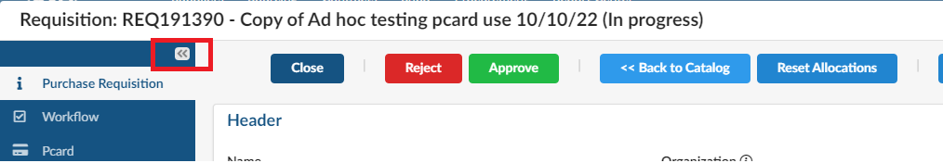

On the right side of the order is the Alerts/Messaging feature. This feature may open automatically if content has been entered.
If closed, an orange Alert icon is shown directly under the print icon. Click on the triangle to open the Alerts/Messaging feature.
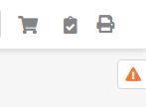

The Messaging feature allows comments and attchments back and forth between buyers and approvers.

The message is ‘attached’ to the requistion and is available to all who view the order.
Adding the buyer or approver name within the Contact field is optional. Add a Message, add an attachment if you wish, and submit before Rejecting or Approving the order. This feature is particularly helpful to note what you have edited on the order and/or why the order was Rejected by the approver.
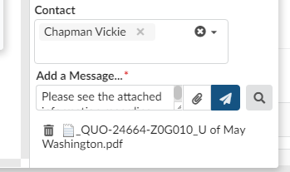

Scroll Down to Items and Services and Use the scroll bar at the bottom of the page for an overview of Item Description and Cost.

Items Detail Window>Item and Services
Selecting the pencil icon will open the Item Details Window. This view will include Internal Comments and Attachments for the specific line item under review. Your permissions may allow a comment by line item. Buyers are taught to use the Header Comments (viewed under Internal Comments) and PO Header Attachments (viewed under Attachments) for ease of approver readability, but there is nothing to disallow the comment entry or attachment at the line level.
Based on security, approvers can usually edit:
Accounting Allocations (foapals)
Line item comments. IF entering comments at the line item, add date and initials

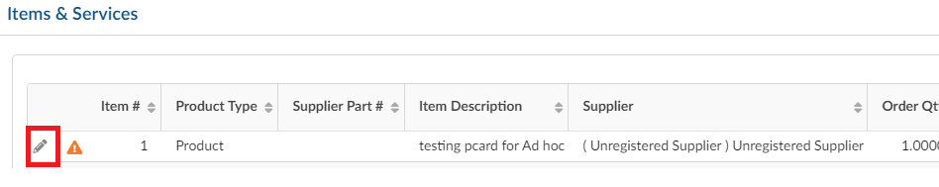

If you opened the Item Details Window to view, be sure to select Save and Save & Close regardless of your editing.

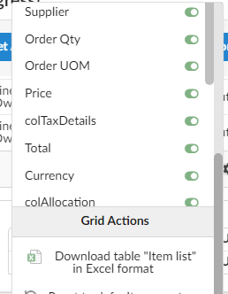

Both the Items and Services and the Allocation Windows have a Gear that allows for mass data extract into excel.
The gear is found on the bottom right on each window. Select the Gear to open the applicable Grid settings (data column content)

Scroll down to open the Allocation Tab for view of FOAPAL descriptions, FOAPAL coding is only visible with the Item Details Window
Scroll down to the Attachments Tab to view Attachments for the full order, as opposed to attachments at the line item level.
Scroll down to the Internal Comments tab to view comments for the full order, or Header Comments as opposed to comments at the line item level.
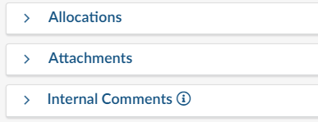
Approve or Reject the Order using the appropriate button options. Rejection allows for a free form text field the user can view on the Workflow history- but also use the Messaging feature and send the message before rejecting or approving the order.

Sample Rejection Reason. The Confirm button will submit the rejection
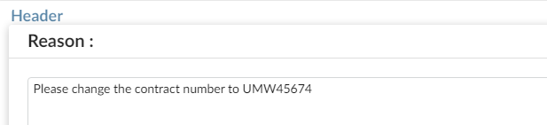
Rejected Order comments are visible via the left blue navigation menu.
Select the Workflow icon 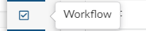
Open Previous Approvals and Refusals
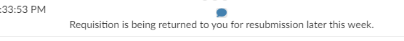

Add an Approver
On the left blue side menu, select Workflow>Upcoming Approvals & Ad hoc and then click on the person icon within the blue side menu

Within the Adhoc Approvers block, select Insert Approvers
Within the Adhoc Approvers field, insert the name of the person who will approve the order and/or add their charge card to the order. You may add more than one approver to the order.
In the When column, choose Before or After the Pre—Defined rules already noted within the Organization Rules (current approvers and workflows) listed for the order. Type in the Reason for your request.
The sample below shows a Chapman Jarred added before the current Dollar 2 Approvers.
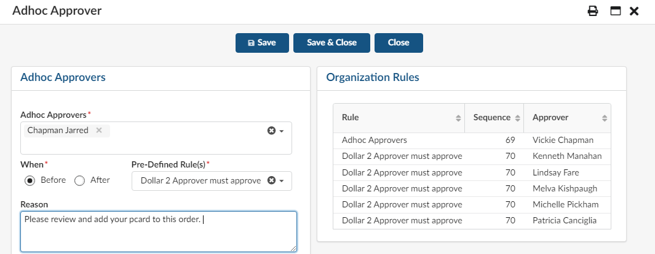

Save and Close the page and navigate back to the Purchase Requisition
Approve or Reject the Order.
