Allocation Grid Settings

The Allocations grid view (within a purchase order) can be customized to remove or reorder columns. This can be useful when viewing FOAPAL information to reduce scrolling, reorder FOAPAL elements and remove unused information.
- Click the gear icon located in the bottom right of the grid.
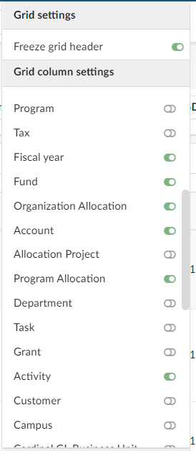
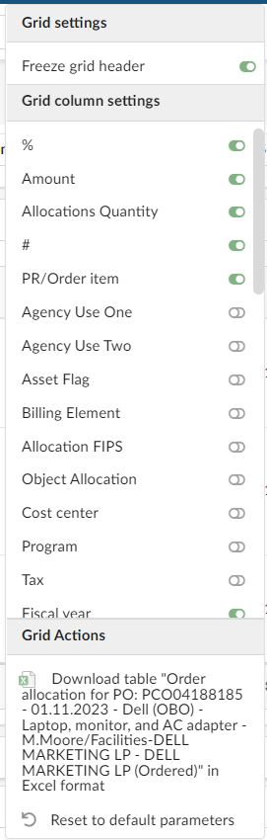
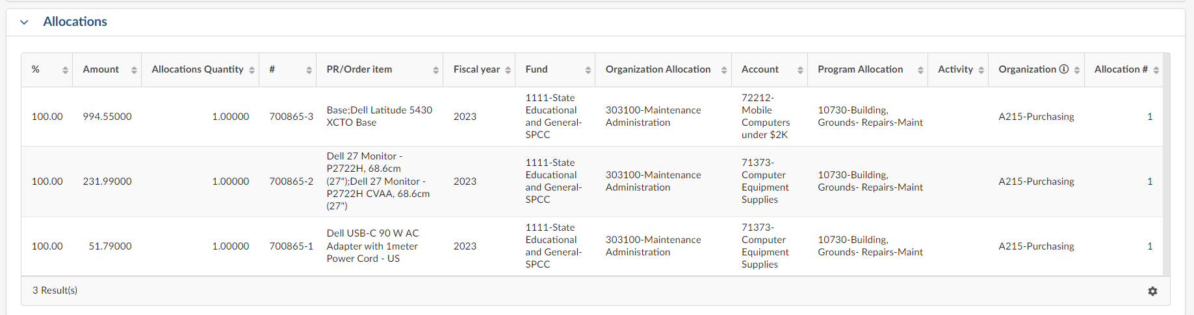

- The Grid settings menu pops open showing all available columns on the grid.
- You may turn columns off/on using the toggle buttons.
- To reorder columns, drag and drop the selected field within Grid Settings. As you drag and drop the Grid reorder in real time.
- In this example I chose:
- %
- Amount
- Allocations Quantity
- #
- PR/Order Item (item description)
- Fiscal Year
- Fund
- Organization Allocation
- Program Allocation
- Activity
- Organization
- Allocation #

