Thank you for your interest in doing business with the University of Mary Washington (UMW). In order to receive payment, follow the instructions provided below.
UMW Accounts Payable requires the Commonwealth of Virginia (COV) W9 and the Vendor Registration Information Form, if attached. PDF files are preferred.
Complete the attached form(s) and use the link below to securely upload the required document(s) via BOX, a cloud-based platform for sending and receiving content securely. The link will be available and active for 10 days. Should the link expire before you are able to submit the document(s) please contact the originator of this email to receive an updated link.

To avoid delays in payment, please be sure to provide the SSN, EIN or TIN that matches the Legal Name on the form. UMW cannot make payment if the legal name doesn’t match the name that the IRS shows related to the SSN, EIN or TIN provided on the form. For more information see the instructions on page 3 of the COV substitute W-9.

Required Secure BOX Link for Document Upload: XXXXXXXX

UMW only accepts wet/ink signature or certified DocuSign or Adobe electronic signature.
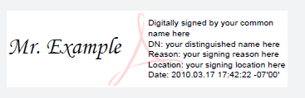
Improperly signed forms and/or leaving questions unanswered will delay vendor setup and possibly delay payment.

If you have any questions regarding uploading the forms in the secure link provided please reach out to us at payables@umw.edu

