Sample Budget review using Fund 1557AS: Undergraduate Research
Banner Admin View
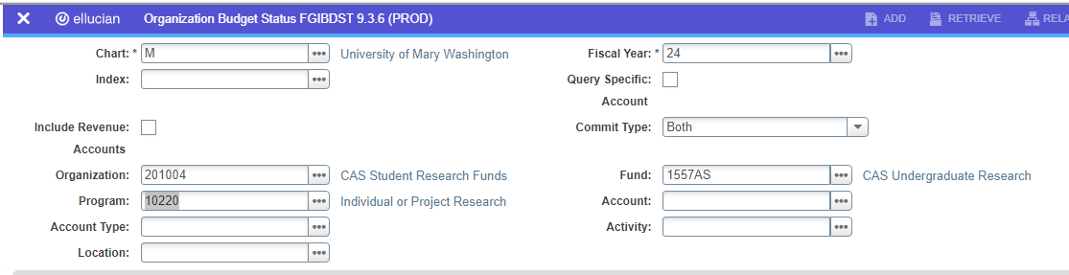

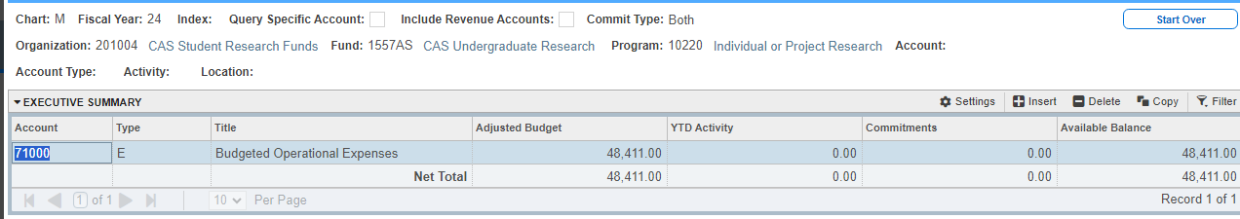

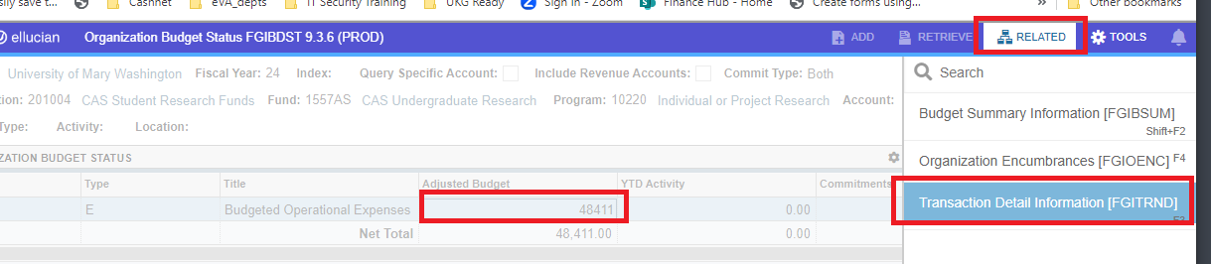

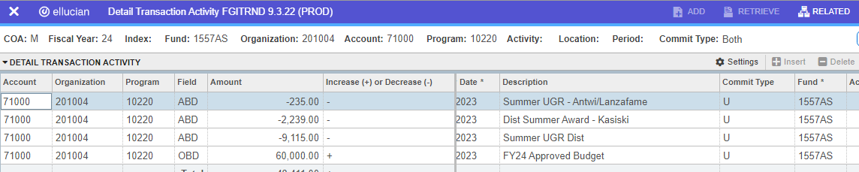

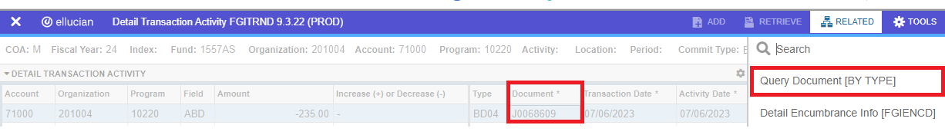

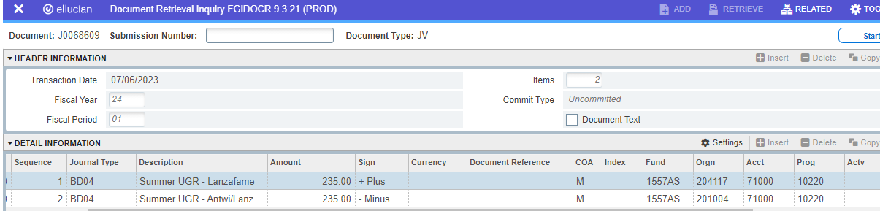

Banner Self Service View using the Budget Status by Account option