PRIOR/NEW YEAR EXPENSES FOR CREDIT CARDS
Expenses paid by credit card on the first two FY25 billing cycles (see tables below) of the SPCC and the UMW Finance Card need to be evaluated to determine if the expense is related to the prior fiscal year (FY24) or the new fiscal year (FY25).

REASON: For the months of July and August, all expenses—including expenses on credit cards—related to prior fiscal year must be recorded in the prior fiscal year for financial reporting to Richmond.

- Cardholders must evaluate their credit card transactions for the July and August cycle end dates and enter PRIOR in the location field in WORKS if the expense is related to FY24.

- Cardholders will leave the location field in WORKS blank if the expense is related to FY25.

- Regardless of which year the expense is related to, the cash will come out of FY25 budgets; however,
On the FY24 financial statement the expenses will be reflected as a FY24 expense.

SPCC Month | Cycle Start Date | Cycle End Date | Works Statement Available | Sign Off Deadline | Add PRIOR to the GL Location code in Works if the goods were received or services were performed on or before June 30.
July | Jun 15 | July 15 | July 17 | July 18
August | July 16 | Aug 15 | Aug 17 | Aug 20

UMW Finance Card Month | Cycle Start Date | Cycle End Date | Works Statement Available | Receipt Packet Due to  Debra Cash in Accounts Payable | Add PRIOR to the GL Location code in Works if the goods were received or services were performed on or before June 30.  Does not apply to 8 funds.
July | Jun 26 | July 25 | July 27 | Aug 2
August | July 26 | Aug 25 | Aug 27 | Sept 2

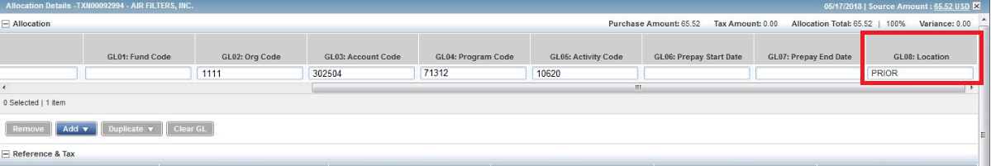

Questions to ask yourself to determine whether the expense needs to be captured for the prior fiscal year (by entering PRIOR in the location field in WORKS) or the new fiscal year (by leaving the location field blank in WORKS):

FOR GOODS
Was this payment for a good that was received prior to July 1st?
- If NO, then leave the location field blank in WORKS
- If YES, then enter PRIOR in the location field in WORKS
- If the goods were received in different shipments on various dates, by what date was the majority of the goods received?
  - If this date is PRIOR to July 1st, then enter PRIOR in the location field in WORKS.
  - If this date is on or AFTER July 1st, then leave the location field blank in WORKS.

FOR SERVICES
What date was the final date of service received?
- If this date is PRIOR to July 1st, then enter PRIOR in the location field in WORKS.
- If this date is on or AFTER July 1st, then leave the location field blank in WORKS.

FOR SUBSCRIPTION/MAINTENANCE AGREEMENTS
How much of the service (for that particular invoice) falls in the prior fiscal year?
- If the majority of the service falls prior to July 1st then enter PRIOR in the location field in WORKS.
- If the majority of the service falls on or after July 1st, then leave the location field blank in WORKS.

Examples: Subscription runs from 5/2024-4/2025 New year expense
Maintenance agreement 7/2024-6/2025 New year expense
Maintenance agreement 11/2023-10/2024 PRIOR year expense

Examples with Invoices
Professional Building
Invoice received 6/19/2024
Service Received 5/19/2024
PRIOR year expense (enter PRIOR in location field in WORKS) Service was completed in PRIOR FY

bePress
Invoice received 6/29/2024
Subscription runs 6/28/24-6/27/2025
NEW year expense (location field is left blank in WORKS)

Dell
Invoice received 6/19/2024
Goods received 6/19/2024
PRIOR year expense (enter PRIOR in location field in WORKS) Good were received in PRIOR FY

Instructure
Invoice received 7/7/2024
Subscription runs 8/2024-7/2025
NEW year expense (location field is left blank in WORKS)

Quarles
Invoice received 7/13/2024
Goods received 7/11/2024
NEW year expense (location field is left blank in WORKS)

Quarles
Invoice received 7/13/2024
Goods received 6/29/2024
PRIOR year expense (enter PRIOR in location field in WORKS) Goods were received in PRIOR FY

If you are still having difficulty determining whether the PRIOR location code should be used, please scan a copy of the invoice to payables@umw.edu with the subject line of “PRIOR/NEW”. AP will review the invoice and respond back to the email.

